22 June 2022
206-22

Supporting document 2 to the Decision Regulation Impact Statement

Cost-benefit analysis

P1052 Primary Production and Processing (PPP) Requirements for Horticulture (Berries, Leafy Vegetables and Melons)

Executive summary
This document should be read alongside the Decision Regulation Impact Assessment (DRIS) for P1052.

FSANZ Proposal P1052 — Primary Production and Processing (PPP) Requirements for Horticulture (Berries, Leafy Vegetables and Melons) considers the need for regulatory and/or non-regulatory measures for managing food safety risks in these sectors (berries, leafy vegetables and melons).

FSANZ has considered four possible options:
Option 1 – Maintaining the status quo
Option 2 – Regulatory measures
Option 3 – A combination of regulatory and non-regulatory measures
Option 4 – Non-regulatory measures.

This cost-benefit analysis (CBA) examines each of these options in detail.
These options were assessed in accordance with the Food Standards Australia New Zealand Act 1991 and against the criteria listed in that Act, which include:
- whether costs that would arise from a food regulatory measure developed or varied as a result of the proposal outweigh the direct and indirect benefits to the community, government or industry that would arise from the development or variation of the food regulatory measure
- whether other measures (available to the Authority or not) would be more cost effective than a food regulatory measure developed or varied as a result of the proposal
- any other relevant matters.

From our assessment and after considering stakeholder feedback, the option preferred by FSANZ is option 3. This option would include the development of three primary production and processing standards – one each for berries, leafy vegetables and melons. The standards would contain outcomes-based, minimal food safety requirements to achieve the required food safety outcomes.

In addition, these requirements would be supported by non-regulatory measures such as industry guidance material, a code of practice, and the promotion of food safety culture and training. These non-regulatory measures would be developed collaboratively between government and industry.

FSANZ assessment took account of implementation matters and costs. That said, FSANZ does not make the decision about implementation. Implementation is decided by jurisdictions. Jurisdictions are currently in discussions with industry exploring options including to recognise existing voluntary and market-led food safety schemes (FSS) as being compliant with regulations, and how to reduce auditing burdens. Those discussions between jurisdictions and industry are also around how to reduce costs and increase practicalities for smaller businesses and how to generally reduce unnecessary costs of the proposed measures.

FSANZ’s estimates indicate that option 3 will result in a net benefit of at least $19.5m over a 10-year period. That estimate has been revised downwards significantly since the second call for submissions and Consultation RIS because of a newer and more sophisticated Cost of Illness model substantially revising costs of illness downwards, particularly for Salmonella.

Despite the $19.5m in net benefits estimated, additional potential benefits have not been monetised, including many direct and indirect costs of recalling unsafe or suspect commodities. Recall costs cost jurisdictions in resources, but the main costs are often indirect reputational costs to industry. As an example, Melons Australia (an industry body) estimated a $100m dollar market value loss after the 2018 listeria outbreak in melons.

Table of contents
Executive summary 1
1. Introduction 4
2. Risk management options 4
3. Industry overview 5
Berry production and processing 5
Leafy vegetable production and processing 6
Melon production and processing 6
Summary of business numbers 7
4. Summaries of cost-benefit ratios for each commodity 8
Overarching assumptions for cost-benefit analysis, compared to status quo 8
Summary tables – all options 11
Summary tables – option 3 costs 13
Summary tables – option 3 benefits 16
5. Conclusion 21
6 References 22
Appendix 1 – Business costs 23
Appendix 2 – Expert elicitation 43
Appendix 3 – Government costs of regulatory options 46
Appendix 4 – Costs of the non-regulatory option 49
Appendix 5 – Business costs of a food safety incident: a case study 54
Appendix 6 – International trade 60
Appendix 7 – Consumers 74

Introduction
The purpose of this cost-benefit analysis (CBA) is to inform Food Standards Australia New Zealand’s (FSANZ) decision making. Another CBA was previously part of the consultation documents and accompanied the Consultation Regulation Impact Statement (CRIS) which was released for public consultation in November 2021 as part of the 2nd Call for Submission (CFS) process. This CBA takes account stakeholder feedback from the 2nd CFS process on costs and benefits and of results from a newer, more sophisticated Cost of Illness model.

FSANZ had regard to implementation costs in its assessment. See, for example, sections 2.1 and 2.5.1.1 of the Approval Report and SD1 (DRIS). How the approved draft standards are implemented by the jurisdictions remains a matter for the jurisdictions to determine. FSANZ’s understanding is that jurisdictions have yet to agree on a model for implementation and have committed to work with industry in developing a model. When developing its cost and benefit estimates, FSANZ considered implementation costs such as those associated with rights of entry, licensing, registration and audit to account for the possibility that they may form part of the implementation model adopted by jurisdictions. The draft standards approved by FSANZ do not contain or impose such requirements (for example, Standard 4.2.7 imposes a notification requirement only).

This CBA estimates the relative ratios of costs to benefits of FSANZ’s risk management option 3 of Proposal P1052, i.e. “Minimal outcomes-based food regulatory measures supported by non-regulatory measures developed by industry and government.”

This CBA has relied on the best available information at this point in time, but data gaps remain, even after useful information gathered from consultation. A number of assumptions have still needed to be made, including around licencing, registration and auditing / monitoring. Gaps and assumptions are clearly identified in the analysis.

To mitigate the uncertainty from data gaps, FSANZ has modelled a range of cost to benefit scenarios.

Any licence and audit / monitoring costs to jurisdictions are assumed to be 100% cost-recovered from businesses and are already counted here as business costs.

All costs and benefits are expressed in Australian dollars and are based on:
- average costs per business in each commodity group
- annual health costs
- discounting where cost and benefits are received in the future.

The time dimension is important in valuing costs and benefits; costs and benefits should be valued at the specific time they occur. Since a dollar’s consumption in the future is usually worth less than a dollar’s consumption today, future costs and benefits are discounted to a ‘present value’. There is a lot of discussion about what an appropriate discount rate is within the literature. The OBPR has suggested using a 7% discount rate with discount rates of 3% and 10% used to assess the sensitivity of the result to the discount rate used. Costs and benefits to individual businesses would vary greatly, depending on business size, location and other factors.

Risk management options
FSANZ has examined various risk management options to address the problem of foodborne illness linked to berries, leafy vegetables and melons. These options include:
- Option 1 – Maintaining the status quo
- Option 2 – Regulatory measures
- Option 3 – A combination of regulatory and non-regulatory measures
- Option 4 – Non-regulatory measures

Each option was considered by the CBA in the context of risk, cost-benefit and the appropriateness to the industry sector involved.

There is some variation within each option as they are applied to the different commodity groups. This variation reflects the unique food safety risk profile of each commodity group and the potential costs of managing them. These differences are reflected in our costings for each commodity group.

Industry overview
Australia’s horticulture industry produces fruit, vegetables, nuts, cut flowers, cultivated turf and nursery products. In 2019-20, it was Australia’s third-largest agricultural industry (Department of Agriculture, Water and the Environment (DAWE) 2020). The farm gate value for the 2019–20 financial year was $15.1 billion (b) (Horticulture Innovation Australia Limited (HIAL) 2020b). Over 85% of production is sold into the domestic market. Produce is also traded internationally in a highly competitive market (DAWE 2020).

For 2019–20, the combined farm gate value for the berry, leafy vegetable and melon sectors was $2.04b (HIAL 2020b). There are estimated to be 1,300 to 2,000 primary production and processing operations in these sectors, Australia-wide.

The industry is mostly comprised of small-scale family-owned farms. There is an increasing trend toward medium to larger scale operations. Due to the dynamic characteristics of the fresh produce sector, the number of operations fluctuates between seasons. In 2019–20, around 67,100 people were employed to grow fruit, vegetables and nuts (DAWE 2020).

The length of supply chains moving produce from farm to consumer varies greatly. They can be relatively short (farm directly to consumer) or more complex, involving multiple points, co-mingling and secondary processing.

More information on the Australian berry, leafy vegetable and melon sectors is provided below. General production information was obtained from the Australian Horticulture Statistics Handbook (HIAL 2020a, b). Estimates of the number of primary production and processing operations have been provided by state and territory food regulatory agencies and peak industry bodies; however, some gaps remain. Further industry statistics are provided in Appendix 5.

Berry production and processing
According to Berries Australia in its February 2022 consultation submission, throughout Australia, there are approximately 800 berries growers in total. Data from the Australian Bureau of Statistics (ABS) suggests 260 strawberry growers, 120 rubus berry growers (mainly of blackberries and/or raspberries), and up to 300 blueberry growers. Berries are grown commercially in all Australian states but neither of the territories.

Berry production for 2019–20 was 113,025 tonnes (t), with a value of $1,041 million (m). Strawberry production accounted for almost three quarters (83,310t) of production, with a value of $435m. Blueberries accounted for 20,783t, and were valued at $390m. Rubus berries (blackberries, raspberries and similar) accounted for 9,932t, and were valued at $216m. Of Rubus berry production, 7404t was raspberries and 2,483t was blackberries (HIAL 2020b).

The majority of Australian berry production enters the domestic market, mostly fresh and minimally processed. A small proportion is exported fresh or frozen. In 2019–20, 5,084t of fresh berries were exported from Australia at a value of $42m (DAWE). Of this, 4,678t was strawberries, valued at $33.4m. Blueberry exports were 393t, valued at $8.4m. Rubus berry exports totalled 13t, valued at $0.2m. In addition to fresh berries, 163t of frozen strawberries were exported, and 5,800t of frozen strawberries (and 1,091t of preserved strawberries) were imported. Frozen Rubus berry exports totalled 41t and 9,009t was imported (HIAL 2020b). Imports of fresh berries into Australia were relatively small. The imports were primarily blueberry accounting for 1,644t valued at $36m (2019-20). Strawberry imports were 4t valued at less than $0.1m. There were no imports of fresh Rubus berries (HIAL 2020b).

For the purpose of this analysis ,we have used a central estimate of 750 primary producers and processors or berries, based on estimates from the ABS, regulators, industry and other sources. Jurisdictions estimated 500 berries businesses compared to 1,000 and 800 businesses estimated by Berries Australia in 2020 and 2022 respectively.

Leafy vegetable production and processing
Leafy vegetables (in scope of P1052) are grown commercially in all Australian states but neither of the territories (HIAL 2020b).

In 2019–20, Australia produced a total of 216,435t of leafy vegetables, valued at $842.4m. In its February 2022 consultation submission, AUSVEG estimated that in 2020-21, leafy vegetables, head lettuce and fresh herbs had a combined farm-gate value of $897m, contributing 18.25 per cent to the overall value of vegetable production.

In 2019-20, fresh head lettuce accounted for most production (135,119t), with a value of $206.2m. Fresh leafy salad vegetables accounted for 69,321t, and were valued at $407.5m. Production of fresh leafy herbs accounted for 11,995t, and were worth $228.7m (HIAL 2020b).

Most leafy vegetables are sold domestically. They are available as loose product, and in a washed, bagged and ready-to-eat form. A small volume is exported and imported. In 2019–20, exports of head lettuce totalled 427t, with an export value of $1.3m. Leafy salad vegetable exports totalled 1,345t, with a value of $10m. In 2018–19, there was a small volume imported: 3t of head lettuce and 23t of leafy salad vegetables, which were valued at $0.1m. There is no recorded import or export of leafy herbs (HIAL 2020b).

Previous estimates of 1,500 leafy veg businesses +/- 500 in Australia have been substantively questioned by stakeholders and there is stronger evidence to support a significantly lower number of businesses, including ABS data. Therefore, for the purpose of this analysis, we have substantially revised our estimate downwards to a central estimate of 640 primary producers and processors of leafy vegetables. The 640 figure is based on estimates from ABS, also taking into account information provided from industry, jurisdictions and other stakeholders. AUSVEG in its February 2022 consultation submission estimated 302 lettuce growers.

Melon production and processing
According to the Australian Melon Association (February 2022 consultation submission), there are approximately 200 melons businesses across Australia. Melons are produced in all states and territories except Tasmania and the ACT. Queensland and New South Wales have the largest growing areas (HIAL 2020b).

In 2019–20, Australia produced 190,024t of melons, valued at $152m. Watermelon accounted for most of this production (131,889t), with a value of $84m. Muskmelons accounted for 58,136t, valued at $68.4m. Of muskmelon production, 49,415t was rockmelon, 8,139t was honeydew melon and 581t was piel de sapo melon (HIAL 2020b).

Most melon is sold on the domestic market. Melons are also exported and imported. In 2019–20, 21,772t of melon was exported, at a value of $39.3m. Muskmelon exports accounted for 14,887t, with a value of $26.2 m. Watermelon exports accounted for 6,885t, and were valued at $13.1m. There are minimal imports. In 2019–20, 155t of watermelon were imported into Australia, with a value of $0.2m; and no muskmelons were imported (HIAL 2020b).

For the purpose of this analysis, we have used a central estimate of 225 primary producers and processors of melons, based on estimates from ABS, regulators, industry and other sources.

Summary of business numbers
The following table provides a summary of the total number of businesses in each sector for our cost-benefit analysis. The percentage of businesses not currently on a FSS has also been provided.

Table 1 – Total numbers of businesses and numbers of businesses not on a voluntary scheme
 | Berries | Leafy vegetables | Melons
Estimated total numbers of businesses across all of Australia, whether or not on a voluntary scheme. All such businesses would be affected by the notification (berries) and are assumed to be affected by licensing (leafy vegetables and melons) components of the proposed food measures | 750 +/- 250, i.e.  500 (low)  750 (central)  1,000 (high) | 640 +/- 120, i.e.  520 (low)  640 (central)  760 (high)  Substantively updated after consultation feedback. | 225 +/- 75, i.e.  150 (low)  225 (central)  300 (high)
Estimated % and number of businesses not on a voluntary food safety scheme (February 2022). | 25%  500 x 25% (low) = 125  750 x 25% (central) = 188  1,000 x 25% (high) = 250 | 50%  520 x 50% (low) = 260  640 x 50% (central) = 320  760 x 50% (high) = 380 | 5%  150 x 5% (low) = 8 (7.5)  225 x 5% (central) = 11  300 x 5% (high) = 15

These figures were derived from the following sources:
- Australian Bureau of Statistics (ABS) spreadsheet: 71210DO004_201920 Agricultural Commodities, Australia–2019-20 and 2020-21
- Horticulture Innovation Statistics Handbook 2018/19
- Freshcare submission to P1052 1st Call for Submissions
- A FSANZ survey of state and territory food regulation and primary industries agencies in June 2020, seeking estimates of business numbers and coverage of voluntary food safety schemes in their jurisdiction
- A FSANZ request to industry associations for business numbers in November 2020
- Information received from submitters during the 2nd Call for Submissions to February 2022.

There was some variation in estimated numbers between different sources. FSANZ broadly took an average estimate of business numbers.

Summaries of cost-benefit ratios for each commodity
FSANZ has estimated the range of cost-benefit ratios for each commodity group that could be expected by implementing the various options. These are presented in the tables. Several assumptions were made and these are described below.

Overarching assumptions for cost-benefit analysis, compared to status quo
- “Businesses” referred to here are primary producers or processors as defined in the scope of the Proposal P1052.

- The costs of option 3 assumed to be incurred by businesses may include:
- monetary fees, such as licence fees and costs of ensuring safer and suitable inputs (water, soil, etc.)
- spending, such as spending on new equipment
- costs of staff time diverted from commercial activities, such as staff time taken to attend training or to apply for any licensing or notification of businesses.

NB: Specific implementation and associated fees for requirements under standards is at the discretion of the jurisdictions and will be decided upon during implementation.

- Costs of staff time are assumed as:
  - $60 per hour for manager
  - $40 per hour for another worker
  - $70 per hour for an industry representative

FSANZ’s estimate of the hourly rate for non-managers was based on data obtained from the TQA Australia report ‘Quantifying the costs of compliance with quality assurance 2011’.
This hourly rate includes the total value of the worker’s hours to a business, including overheads, wages, etc. The hourly rate also included on-costs such as superannuation and leave loading.
The TQA estimates were adjusted for Producer Price Inflation (PPI) between 2011 and 2021 and rounded-up to allow for some labour shortage inflation during and post-COVID 19. For example, hourly rates quoted in the TQA report were between $35 and $40 (after PPI) and were rounded up by FSANZ to $40.
FSANZs estimate of the hourly rate for managers was extrapolated from the rate for non-managers.

- Health benefits include fewer illnesses in Australia that are a direct result of Option 3 being implemented. Such health benefits consist of:
- reduced health care costs, e.g. fewer people requiring treatment for foodborne illness caused by eating unsafe produce.
- reduced productivity losses from people not being able to work during their illness.
- reduced pain and suffering for individuals (willingness to pay proxy used).

- Any reduced burdens to regulators from reduced food-borne illnesses have not been counted.

- We are only quantifying direct first round impacts for all costs and benefits.

- Reputational benefits to industry and trade have not been quantified.

- Many businesses that produce the three commodity groups in Australia are voluntary signatories to a food safety scheme (FSSs) such as Freshcare or HACCP or other relevant schemes. It is assumed that only businesses not already on an existing voluntary scheme would incur most costs of the regulatory components of Option 3. That is apart from any relevant licensing requirements that may apply to leafy vegetables and melons businesses. It is assumed that businesses already on an FSS would only incur licence costs and not audit / monitoring costs.

- For the purposes of this analysis, it is assumed that only limited benefits would arise from those businesses already on a FSS.

- The estimates of business numbers are in the table below. The business numbers are derived from data supplied by state and territory governments, ABS data, Freshlogic data and information supplied from industry.

- The central estimate of business numbers have been used for the cost-benefit analysis. That is because of the significant uncertainty around two other major variables: efficacy of proposed food measures and average cost per business. Modelling ranges for the latter two major variables whilst keeping estimated business numbers constant is consistent with good practice sensitivity analysis.

- Costs and benefits only relate to reducing illnesses caused by microbiological hazards of commodities and do not cover illnesses from chemical or physical contamination or other causes.

- For the purposes of the cost-benefit analysis, the assumption has been made that no businesses within the defined categories (of berries, leafy vegetables and melons producers or processors) will be exempt from the proposed requirements.

- For the purposes of the cost-benefit analysis the assumption has been made that no testing of commodities, seeds, soil or water is necessary. Instead, documentation must show that:
  - seeds and seedlings have been sourced from a reputable supplier
  - soil, fertilisers and manure meets industry standards or has been sufficiently treated
  - non-potable water has been treated e.g. with chlorine.

- Costs of lost commodities due to spoilage have not been counted.

- It is assumed that even for businesses not already on an FSS, around half of all food safety activities required by the regulatory components of Option 3 are being done anyway. Therefore, is has been assumed businesses not on a voluntary food safety scheme are only expected to incur 50% of the estimated costs. Some submitters during consultation gave opinions that substantially less than half of such activities are already being done by businesses not already on an FSS, but were unable to provide any decisive evidence for that. If less than half of all food safety activities required by the regulatory components of Option 3 are being done by businesses not already on an FSS, the DRIS would over-estimate net benefits of the preferred options. That would further increase the importance of reducing costs and exemptions for smaller businesses. Note that assumed notification, licences and audit costs have not been deflated by 50% in our existing calculations.

- For the non-regulatory components of options 3 and 4, it is assumed that costs consist of three components:
- Costs to businesses of familiarising themselves with good practice food safety operations, assumed to be the same as initial costs of familiarising with the legislation (for option 3)
- Costs to industry of having peak body involvement in collaborating in the design of fact sheets, animations and webinars and attending face-to-face meetings
- Costs to jurisdictions of implementing the non-regulatory option, including the design and publication of fact sheets, animations and webinars and attending face-to-face meetings
The above cost components (2) and (3) are explained in more detail in Appendix 4.

Summary tables – all options
The following tables show the ranges of cost-benefit ratios for each commodity group that could be expected by implementing the various options.

Table 2. Summaries of cost-benefit ratios for options 2, 3 and 4, benchmarked against the status quo – central efficacy ranges – non-regulatory to regulatory plus option
Commodity group | Regulatory-only  option 2^{b} | Regulatory-plus  option 3^{cd} | Non- regulatory option 4ª
Berries  Harvest and packing season assumed as 210 days a year (updated estimate during consultation) | $0.2 to $0.7 = Costs to $1 benefit  Net benefits likely  Assumed efficacy = 15% | Reduction of less than 0.1% of illness cases over 10 years would justify benefits of implementing the non-regulatory component above option 2. Marginal efficacy compared to option 2 likely to be very small, but assumed as large enough to provide a positive return relative to small additional cost. | Reduction of less than 0.1% of illness cases over 10 years would justify benefits of implementing the additional non-regulatory measures over ten years.
Leafy vegetables  Almost all-year round harvest and packing season assumed of 310 days a year | $0.3 to $1.0 = Costs to $1 benefit  Central estimate of $0.7 = Costs to $1 benefit  Assumed efficacy = 40% because higher numbers of leafy vegetables business are not yet on a voluntary food safety scheme. | Reduction of less than 0.1% of illness cases over 10 years would justify benefits of implementing the non-regulatory component. Marginal additional efficacy compared to option 2 is likely to be small, but assumed as large enough to provide a positive return relative to small additional cost. | Reduction of less than 0.1% of illness cases over 10 years would justify benefits of implementing the additional non-regulatory measures over ten years.
Melons  Harvest and packing season assumed as 60 days a year | $0.1 to $0.2 = Costs to $1 benefit  Net benefits likely  Assumed efficacy = 20% | Reduction of less than 0.1% of illness cases over 10 years would justify benefits of implementing the non-regulatory component. Marginal additional efficacy compared to option 2 is likely to be small, but assumed as easily large enough to provide a positive return relative to small additional cost. | Reduction of less than 0.1% of illness cases over 10 years would justify benefits of implementing the additional non-regulatory measures over ten years.
a. Efficacy of the non- regulatory options has not been analysed. Without regulatory back-up, non-regulatory guidance is likely to have very marginal impacts.
b. *Based on central prediction of effectiveness (efficacy) of options reducing current Australian annual foodborne illnesses originating in the growing, harvesting or initial processing of each commodity. Central business costs +/-50%
c. Includes both regulatory option 2 and non-regulatory option 4.
d. Costs of option 4 = The costs of industry peak body representatives collaborating in the design of fact sheets, animations and webinars and attending face-to-face meetings. Total costs of $9,240, divided by 3 for each of the three sectors.

Summary tables – option 3 costs
The following tables show the ranges of cost-benefit ratios for each commodity group that could be expected by implementing option 3. Business costs are further described in Appendix 1.

Table 3. Summary of estimated total costs to industry of implementing option 3
 | Berries |  | Leafy vegetables |  | Melons
Numbers of businesses not on a voluntary food safety scheme | 188 |  | 320 |  | 11
Numbers of businesses already on a voluntary food safety scheme | 562 |  | 320 |  | 214
 | Initial costs $ | Ongoing costs per year $ | Initial costs $ | Ongoing costs per year $ | Initial costs $ | Ongoing costs per year $
LOW estimate - per business (not already on a voluntary scheme) | 265 | 828 | 350 | 3,518 | 350 | 2,028
LOW estimate - total industry costs = Medium x 50% | 59,665 | 155,296 | 113,540 | 1,230,318 | 5,478 | 92,708
MEDIUM estimate - per business (not already on a voluntary scheme) | 530 | 1,656 | 700 | 7,035 | 700 | 4,055
MEDIUM estimate - total industry costs | 119,330 | 310,592 | 227,080 | 2,460,637 | 10,955 | 185,417
HIGH estimate - per business (not already on a voluntary scheme) | 795 | 2,485 | 1,050 | 10,553 | 1,050 | 6,083
HIGH estimate - total industry costs = Medium x 150% | 178,995 | 465,888 | 340,620 | 3,690,955 | 16,433 | 278,125
Notes: Some figures may not precisely add due to rounding to nearest $1
In the table, “Initial costs” are the one-off costs to businesses for ensuring compliance at the start, e.g. registering their business, familiarising themselves with the new legislation, upgrading equipment to improve irrigation. “Ongoing costs” are costs to businesses for ensuring ongoing compliance. Total industry costs are after an additional cost has been added for the non-regulatory component of option 3 (identical to option 4): $9,240: costs of industry peak body representatives collaborating in the design of fact sheets, animations and webinars and attending face-to-face meetings. Total costs of $9,240, divided by 3 for each of the three sectors.

Table 4. Details of estimated total costs to industry of implementing option 3
 | Berries |  | Leafy vegetables |  | Melons
 | Initial costs $ | Ongoing costs per year $ | Initial costs $ | Ongoing costs per year $ | Initial costs $ | Ongoing costs per year $
Per business
Average costs per business not on a voluntary food safety scheme, excluding notification, assumed licensing and monitoring. This assumes that businesses not already on a voluntary food safety scheme incur full costs of the proposed primary production standard (PPS). | 1,000 | 3,313 | 1,400 | 10,993 | 1,400 | 5,033
Average costs per business not on a voluntary scheme, excluding assumed licensing and monitoring. This assumes that businesses not already on a voluntary food safety scheme incur 50% of full costs of the proposed PPS. | 500 | 1,656 | 700 | 5,496 | 700 | 2,516
Average costs of notification (Berries), or assumed licensing and monitoring (Melons and Leafy Vegetables) | 30 | 0 | 0 | 1,540 | 0 | 1,540
Notes on notification, assumed licensing and monitoring costs | $30 in staff time - one-off and notification only |  | $1,540 a year total (rounded), i.e. $654 annual licensing costs, plus $885 monitoring costs. This average will vary greatly by business according to size, location and other factors. Businesses already on a voluntary scheme are assumed not to incur audit costs. |  | $1,540 a year total (rounded), i.e. $654 annual licensing costs, plus $885 monitoring costs. This average will vary greatly by business according to size, location and other factors.  Businesses already on a voluntary scheme are assumed not to incur audit costs.
Total estimated average cost per business not on a voluntary food safety scheme - informs MEDIUM industry sector costs below | 530 | 1,656 | 700 | 7,035 | 700 | 4,055
Average per business cost minus 50% - informs LOW industry sector costs below | 265 | 828 | 350 | 3,518 | 350 | 2,028
Average per business cost plus 50% - informs HIGH industry sector costs below | 795 | 2,485 | 1,050 | 10,553 | 1,050 | 6,083
Numbers of businesses not on an existing voluntary food safety scheme | 187.5 |  | 320 |  | 11
Numbers of businesses already on an existing voluntary food safety scheme | 562.5 |  | 320 |  | 214
Industry totals
Estimated industry sector costs – LOW (only for businesses not on a voluntary food safety scheme) | 49,688 | 155,296 | 112,000 | 1,125,678 | 3,938 | 22,812
Estimated industry sector costs – LOW - AFTER adding costs for businesses on a voluntary food safety scheme and non-regulatory costs to business = medium costs x 50% | 59,665 | 155,296 | 113,540 | 1,230,318 | 5,478 | 92,708
Estimated industry sector costs – MEDIUM (only for businesses not on a voluntary food safety scheme) | 99,375 | 310,592 | 224,000 | 2,251,357 | 7,875 | 45,624
Estimated industry sector costs – MEDIUM - AFTER adding costs for businesses on a voluntary food safety scheme and non-regulatory costs to business | 119,330 | 310,592 | 227,080 | 2,460,637 | 10,955 | 185,417
Estimated industry sector costs – HIGH (only for businesses not on a voluntary food safety scheme) | 149,063 | 465,888 | 336,000 | 3,377,035 | 11,813 | 68,436
Estimated industry sector costs – HIGH - AFTER adding costs for businesses on a voluntary food safety scheme and non-regulatory costs to business = medium costs x 150% | 178,995 | 465,888 | 340,620 | 3,690,955 | 16,433 | 278,125
Notes: Some figures may not precisely add due to rounding to nearest $1. An additional cost has been added for the non-regulatory component of option 3 (identical to option 4): $9,240. The $9,240 covers all three industry sectors combined.

Summary tables – option 3 benefits
When estimating the benefits of reducing illnesses, FSANZ took the data of illnesses that are officially notified to health authorities and then applied an estimated multiplier for under-reporting. For instance, FSANZ understands from expert elicitation that there are eight times as many STEC illness cases as are notified to health authorities.

Other benefits not quantified here may include:
- Inventory management and other business management benefits
- Potential additional sales in export markets
- Government’s improved capacity to effectively and efficiently manage a food safety incident, reducing costs
- Avoided losses to avoided recalls and incidents

While there are unlikely to be substantial benefits to exports from changes to our domestic regulation, substantial additional benefits to industry will exist in terms of the avoided costs associated with outbreaks and incidents. Some additional costs will also be borne by government in implementing and enforcing a new regulatory regime.

Net benefits estimates over a ten-year period, with three different percentage discount rates (3, 7 and 10%) are shown in the tables below. Estimated costs of illness and estimated benefits of reducing illnesses are based on a cost model that accounts for costs of visits to GPs (doctors) from a food-borne illness, hospitalisations for some people with a food-borne illness, lost working days, willingness to pay money to avoid illnesses and the value of a human life for those that die from a food-borne illness.

Note that since consultation, the updated Cost of Illness model led to revised annual costs of illness and benefits of reducing illness, particularly for Salmonella in leafy vegetables and melons.

Table 5. Benefits of reducing illnesses and their associated annual costs across Australia after implementation of option 3.
Commodity | Pathogens contributing to foodborne illness
 | Listeria  cost/year | STEC  cost/year | Salmonella  cost/year | Norovirus  cost/year | Hepatitis A  cost/year | Total illness  cost/year |  | Plausible range in estimated illness cost savings per year benefits | Base estimate of illness cost savings per year benefits
Berries | Not applicable | $178,050  *41 est. cases p.a.  *Eight times as many as reported | Not applicable | $4,262,190  *10,763 est. cases p.a.  * Much more than reported | $0  *Around five reported p.a., but almost all originate from imports | $4,440,240 |  | $0.2m to $2.2m  based on 5% to 50% efficacy | $0.7m  based on 15% efficacy
Leafy vegetables | $4,135,969  *Five est. acute cases p.a.  *As many as reported | $890,248  *206 est. cases p.a.  *Eight times as many as reported | $4,268,864  *1,881 est. cases p.a.  *Seven times as many as reported | Not applicable | Not applicable | $9,295,081 |  | $0.9m to $6.5m  based on 10% to 70% efficacy | $3.7m  based on 40% efficacy
Melons | $4,797,724  *Six est. acute cases p.a.  * As many as reported | Not applicable | $2,259,987  *996 est. cases p.a.  *Seven times as many as reported | Not applicable | Not applicable | $7,057,711 |  | $0.7m to $3.5m  based on 10% to 50% Efficacy | $1.4m  based on 20% Efficacy
NA = not applicable, Est. = established, STEC = shiga toxin-producing E. coli.

Table 6. Net benefit estimates over 10 years: 3% p.a. discount rate
Costs to benefit ratios over 10 years NPV | Central business costs $ minus 50% | Central business costs $ | Central business costs $ plus 50%
Berries - low efficacy - 5% | 502,435 | -888,937 | -2,280,309
Berries - central efficacy - 15% | 4,290,050 | 2,898,678 | 1,507,306
Berries - high efficacy -50% | 17,546,700 | 16,155,328 | 14,763,956
Leafy vegetables - low efficacy - 10% | -2,686,514 | -13,301,920 | -23,917,327
Leafy vegetables - central efficacy - 40% | 21,100,165 | 10,484,758 | -130,648
Leafy vegetables - high efficacy - 70% | 44,886,843 | 34,271,436 | 23,656,030
Melons - low efficacy - 10% | 5,217,070 | 4,413,770 | 3,610,470
Melons - central efficacy - 20% | 11,237,441 | 10,434,141 | 9,630,841
Melons - high efficacy - 50% | 29,298,552 | 28,495,252 | 27,691,952

Net Benefit Estimates over 10 years: 7% p.a. discount rate
Costs to benefit ratios over 10 years NPV | Central business costs $ minus 50% | Central business costs $ | Central business costs $ plus 50%
Berries - low efficacy - 5% | 401,919 | -755,480 | -1,912,880
Berries - central efficacy - 15% | 3,520,558 | 2,363,158 | 1,205,758
Berries - high efficacy -50% | 14,435,793 | 13,278,393 | 12,120,993
Leafy vegetables - low efficacy - 10% | -2,233,307 | -10,995,089 | -19,756,872
Leafy vegetables - central efficacy - 40% | 17,352,122 | 8,590,339 | -171,444
Leafy vegetables - high efficacy - 70% | 36,937,550 | 28,175,767 | 19,413,984
Melons - low efficacy - 10% | 4,293,417 | 3,629,793 | 2,966,170
Melons - central efficacy - 20% | 9,250,458 | 8,586,834 | 7,923,211
Melons - high efficacy - 50% | 24,121,580 | 23,457,956 | 22,794,333

Net Benefit Estimates over 10 years: 10% p.a. discount rate
Costs to benefit ratios over 10 years NPV | Central business costs $ minus 50% | Central business $ costs | Central business costs $ plus 50%
Berries - low efficacy - 5% | 343,275 | -677,617 | -1,698,510
Berries - central efficacy - 15% | 3,071,610 | 2,050,718 | 1,029,825
Berries - high efficacy -50% | 12,620,783 | 11,599,890 | 10,578,998
Leafy vegetables - low efficacy - 10% | -1,968,890 | -9,649,205 | -17,329,520
Leafy vegetables - central efficacy - 40% | 15,165,385 | 7,485,070 | -195,245
Leafy vegetables - high efficacy - 70% | 32,299,660 | 24,619,345 | 16,939,030
Melons - low efficacy - 10% | 3,754,526 | 3,172,395 | 2,590,263
Melons - central efficacy - 20% | 8,091,184 | 7,509,052 | 6,926,921
Melons - high efficacy - 50% | 21,101,157 | 20,519,026 | 19,936,894

Table 7. Cost-benefit ratios for implementing option 3
Commodity group | Central efficacy rangeª | Extreme – Worst case efficacy range^{b}
Berries  Harvest and packing season assumed as 210 days a year (updated estimate) | $0.2 to $0.7 = Costs to $1 benefit  Net benefits likely  Assumed efficacy = 15% | $0.7 to $2.2 = Costs to $1 benefit  If efficacy was only 5%
Leafy vegetables  Almost all-year round harvest and packing season assumed of 310 days a year | $0.3 to $1.0 = Costs to $1 benefit  Central estimate of $0.7 = Costs to $1 benefit  Assumed efficacy = 40% because higher numbers of leafy vegetables businesses are currently not on a voluntary food safety scheme. | $1.3 to $4.0 = Costs to $1 benefit  If efficacy was only 10%
Melons  Harvest and packing season assumed as 60 days a year | $0.1 to $0.2 = Costs to $1 benefit  Net benefits likely  Assumed efficacy = 20% | $0.1 to $0.4 = Costs to $1 benefit  Net benefits still very likely  If efficacy was only 10%
a. Based on the central prediction of effectiveness (efficacy) of option 3 to reduce Australian annual foodborne illnesses originating in the growing, harvesting or initial processing of each commodity. Central business costs +/-50%
b. Less likely scenario based on lowest efficacy of option 3

If jurisdictions can reduce some of the costs and make some aspects of compliance easier for smaller businesses, that may contribute to further improving the net benefit ratios.

Conclusion
Based on the CBA assessment, FSANZ’s risk assessment and the current lack of national or consistent food safety regulatory requirements, our preferred approach is the development of minimal regulatory measures that are supported by non-regulatory measures (option 3).

The evidence suggests that through-chain risk factors should be managed to minimise the risk of incidents of foodborne illness associated with horticulture. FSANZ considers that, in general, the Australian horticulture industry produces horticulture produce with a high level of food safety. This is supported by horticultural produce agreements and industry initiatives such as commercial food safety schemes. However, the current system needs strengthening.

Existing food safety schemes in Australia for fresh produce cover the requirements that would be in the proposed PPP standards. However, PPP standards will ensure consistency for all berry, leafy vegetable and melon businesses.

PPP standards mean consistency and transparency for industry and government, improvements in food safety practices in businesses, increased consumer confidence and business sustainability. In addition, national standards improve transparency and demonstrate regulatory requirements to our export destinations and trading partners. As per the analysis in this report, option 3 is also likely result in the largest net benefit to the community.

Implementation measures to assist small businesses may further increase overall net benefits of regulatory options 2 and 3.

6 References
Australian Government Department of Agriculture, Water and the Environment (DAWE) (2019) Horticulture fact sheet. DAWE, Canberra. https://www.agriculture.gov.au/ag-farm-food/hort-policy/horticulture_fact_sheet#production-statistics. Accessed 22 June 2020

DAWE (2020) Horticulture. Australian Government Department of Agriculture, Water and the Environment, Canberra. https://www.agriculture.gov.au/ag-farm-food/hort-policy. Accessed 22 June 2020

DAWE ABARES (2021) Agricultural commodities data tables.
https://www.agriculture.gov.au/abares/research-topics/agricultural-outlook/agriculture-overview. Accessed 22 April 2021

FSANZ (2012) Call for submissions – P1015. Food Standards Australia New Zealand, Canberra. https://www.foodstandards.gov.au/code/proposals/Documents/P1015%20Horticulture%20PPPS%201CFS%20FINAL%20v2.pdf. Accessed 22 June 2020

Hort Innovation Australia Limited (HIAL) (2020a) Australian Horticulture Statistics Handbook 2018/19. HIAL, Sydney. Accessed 10 June 2020

HIAL (2020b) Australian Horticulture Statistics Handbook 2019/20. HIAL, Sydney.
https://www.horticulture.com.au/growers/help-your-business-grow/research-reports-publications-fact-sheets-and-more/grower-resources/ha18002-assets/australian-horticulture-statistics-handbook/ Accessed 3 April 2021

Personal communication (2020a) written comment: in response to 1st call for submissions – Proposal P1052 primary production and processing requirements for high-risk horticulture from Australian Melon Association Inc (AMA) to Food Standards Australia New Zealand 18 March 2020

Personal communication (2020b) written comment: Proposal P1052 primary production and processing requirements for high-risk horticulture from Berries Australia to Food Standards Australia New Zealand 26 March 2020

Australian Bureau of Statistics, ABS Stats: 71210DO004_201920 Agricultural Commodities, Australia–2019-20: https://www.abs.gov.au/

Appendix 1 – Business costs
This appendix adds details to the figures and assumptions outlined in the cost-benefit analysis (CBA).

Costs and assumptions are provided for an average berry, leafy vegetable and melon business. Actual costs will vary markedly by business size, location and other factors. Estimated average costs are provided. A small selection of studies have been used to assist us in our estimates (referenced at the end of this appendix) and other information sources. However, an activity based costing approach has largely been taken to develop estimates given the lack of published studies on these sort of costs. FSANZ has assumed zero compliance before the implementation of standards, and then discounted for 50% compliance for businesses not already on voluntary schemes. Managers have been costed at $60 per hour; other staff members at $40 per hour.

Business costs - berries – businesses without a voluntary FSS

Proposed and assumed requirements | Initial cost $ | Annual ongoing costs $ | Assumptions
Notification  An indivisible cost only counted in final total costs, bottom row. | 30 | 0 | Business notification is assumed as taking 30min of manager time at $60 per hour.  Costs to jurisdictions are not counted here or anywhere else in this spreadsheet. It has been suggested that costs to state and territory governments will be negligible as notification will be captured in existing IT systems.  Unlike for leafy vegetables and melons, neither a food safety management statement nor licensing is required for berries.
Traceability | 0 | 100 | There is likely to be low additional costs. Record keeping is already required for tax purposes, i.e. documenting sales and purchases.
Inputs – soil, soil amendments and fertiliser | 120 | 200 | Testing of soil, soil amendments and fertilisers will not be prescribed by the standard.  Plastic mulch will not be mandatory.  Composting soil, soil amendments and fertilisers (where required) is assumed to take an average of five hours a year at $40 per hour, including documentation.  We have assumed an initial one-off cost of sourcing appropriate soil, soil amendments and fertilisers of two hours of manager time at $60 per hour.  Cost estimates do not include any extra ongoing costs of souring and purchasing soil, soil amendments or fertilisers compared to what is purchased currently.
Inputs – water | 400 | 200 | Testing of water will not be prescribed by the standard.  We have assumed a one-off costs of $400 to improve irrigation methods and to ensure water is potable or set-up treatment. Ongoing costs of $200 a year for chlorine treatment.  Includes documentation that water is suitable.  After weather events, quality will need to be monitored or adjusted.  Some jurisdictions may have legislation about safe water which would already need to be complied with regardless of any new PPP requirements.
Premises and equipment | 0 | 668 | Initial premises and equipment costs were estimated as $3,340 by Tasmanian Quality Assurance (TQA) Australia’s 2011 survey, after PPI adjustment.  Relevant capital assumed to last five years.  Ongoing cleaning counted as cleaning costs below.  Ongoing maintenance, depreciation and replacement costs assumed to be one fifth of initial infrastructure costs of $3,340.  Includes modifications for adequate storage.
Cleaning of premises and equipment | 0 | 1,600 | Cleaning is assumed to take 10 min a day (beyond business as usual) of staff time at $40 per hour; on-going, not a one-off.  Assumed 210 working days in one year for ensuring equipment is adequately clean.  Plus $200 for relevant cleaning materials (ongoing).  Clean water already counted as water testing costs.
Food handling - skills and knowledge | 0 | 345 | Estimates are based on the Melon Card costings. Assumed average of 30 minutes basic training per staff member per year (in addition to the food handling training various businesses already require) for online training plus a $49 fee per staff member for an average of five staff members per business who handle food.  Unknowns include numbers of workers who rotate across different businesses who are already trained for the year or longer.
Health and hygiene requirements | 0 | 200 | Assumed to be mainly counted in premises and equipment, food handling, skills and knowledge and cleaning.  Cost of protective equipment estimated at $200 per year.
Sale and supply | 0 | 0 | Assumed negligible costs on average after other measures have been put in place.
Initial costs of familiarising with new rules | 480 | 0 | Assumed to be eight hours of manager's time at $60 per hour.
Total costs, assuming 0% compliance before the introduction of the proposed requirements | 1,000 | 3,313
Indivisible components  Notifications | 30 | 0 | Even with a general 50% compliance with proposed measures, every berry business will still incur full notification costs.  This cost will also be incurred by businesses on voluntary food safety schemes.
Final total costs per business not on a voluntary food safety scheme - divided by 2 for 50% assumed compliance, then adding indivisible component above | 530 | 1,656

Business costs - berries – businesses with a voluntary FSS

Proposed and assumed requirements | Initial cost $ | Annual ongoing costs $ | Assumptions
Assumed registration / notification | 30 | 0 | Business notification is assumed as taking 30min of manager time at $60 per hour.  Costs to jurisdictions are not counted here or anywhere else in this spreadsheet. It has been suggested that costs to state and territory governments will be negligible as notification will be captured in existing IT systems.  Unlike for leafy vegetables and melons, a food safety management statement is not required for berries.
Final Total costs per berries business already on a voluntary food safety scheme | 30 | 0

Business costs - leafy vegetables - businesses without a voluntary FSS

Proposed and assumed requirements | Initial cost $ | Annual ongoing costs $ | Assumptions
Assumed licensing  Applying for a licence and paying fees to the appropriate regulatory authority.  An indivisible cost only counted in final total costs, bottom row. | 0 | 654 | Assumed re-licencing every year.  Assumed to take 30min of manager time at $60 per hour.  Licencing/re-licencing fees are estimated at $624 each year, based on an average of licence fee figures provided by state and territory governments in April 2021.  Actual licence fees may vary greatly from this average, depending on size and other aspects of a business.  Licence costs may be 100% recovered from state and territory governments, but the extent of likely cost recovery is unknown.
General food safety management requirement  Internal due-diligence by a business | 400 | 1,120 | This requirement is based on the existing general food safety management requirements in Division 2 of Standard 4.1.1.  A one-off cost, estimated to take an average of four hours of manager time at $60 per hour, plus four hours of staff time at $40 per hour.  An additional on-going cost, every three months. An average of two hours of manager time at $60 per hour, plus four hours of staff time at $40 per hour.  There are difficulties estimating the cost of a food safety management statement as they may vary by state and territory.
Assumed audits / monitoring - fees and business time costs per year  An indivisible cost only counted in final total costs, bottom row.  Assumed exemptions from audits for businesses already on a voluntary FSS. | 0 | 885 | Assumed to take four hours of manager time at $60 per hour, plus four hours of staff time at $40 per hour. Costs of staff time: mainly preparation time for audits and being on-call during audits when required.  Fees per audit are estimated to be $485 pa, based on an average of audit fee figures provided by state and territory governments in April 2021.  Actual audit fees may vary greatly from this average, depending on size and other aspects of a business.  Audit costs may be 100% recovered from state and territory governments, but the extent of likely cost recovery is unknown.
Traceability | 0 | 100 | There is likely to be low additional costs. Record keeping is already required for tax purposes, i.e. documenting sales and purchases.
Inputs - seed and seedlings | 0 | 120 | Testing of seed and seedlings will not be prescribed by the standard.  Documentation will be required to prove that e.g. seeds/seedlings have been purchased from a reputable supplier.  Assumed to take two hours of manager time a year at $60 per hour to source appropriate seed/seedlings and to document this.  Training for awareness is already covered in ‘Food handling – skills and knowledge’.  Cost estimates do not include any extra ongoing costs of souring and purchasing safer seed/seedlings, compared to what is purchased currently.
Inputs – soil, soil amendments and fertiliser | 120 | 200 | Testing of soil, soil amendments and fertilisers will not be prescribed by the standard.  Plastic mulch will not be mandatory.  Composting soil, soil amendments and fertilisers (where required) is assumed to take an average of five hours a year at $40 per hour, including documentation.  We have assumed an initial one-off cost of sourcing appropriate soil, soil amendments and fertilisers of two hours of manager time at $60 per hour.  Cost estimates do not include any extra ongoing costs of souring and purchasing soil, soil amendments or fertilisers compared to what is purchased currently.
Inputs - water | 400 | 200 | Testing of water for pathogens will not be prescribed by the standard.  We have assumed a one-off costs of $400 to improve irrigation methods and to ensure water is potable or set-up treatment. Ongoing costs of $200 a year for chlorine treatment.  Includes documentation that water is suitable.  After weather events, quality will need to be monitored or adjusted.  Some jurisdictions may have legislation about safe water which would already need to be complied with regardless of any new PPP requirements.
Growing site, including weather events | 0 | 480 | Commodities made unacceptable by a weather event should not be going to market, regardless of regulation.  The effects of a weather event should be managed as part of normal business. However, biannual environmental risk assessments and production adjustments have been assumed. The time taken to update farm activities to better proactively manage weather events is four hours at $60 per hour.  A weather event that renders a crop unacceptable, e.g. a hail storm, or a flood event, doesn’t have to be an extreme event; what matters is the food safety impact.
Premises and equipment | 0 | 668 | Initial premises and equipment costs were estimated as $3,340 by Tasmanian Quality Assurance (TQA) Australia’s 2011 survey, after PPI adjustment.  Relevant capital assumed to last five years.  Ongoing cleaning counted as a cleaning costs below.  Ongoing maintenance, depreciation and replacement costs assumed to be one fifth of initial infrastructure costs of $3,340.  Includes modifications for adequate storage.
Cleaning of premises and equipment | 0 | 2,267 | Cleaning is assumed to take 10 min a day (beyond business as usual) of staff time at $40 per hour; on-going, not a one-off.  Assumed 310 working days in one year for ensuring equipment is adequately clean.  Plus $200 for relevant cleaning materials (ongoing).  Clean water already counted as water testing costs.
Food handling - skills and knowledge | 0 | 345 | Estimates are based on the Melon Card costings. Assumed average of 30 minutes basic training per staff member per year (in addition to the food handling training various businesses already require) for online training plus a $49 fee per staff member for an average of 5 staff members per business who handle food.  Unknowns include numbers of workers who rotate across different businesses who are already trained for the year or longer.
Health and hygiene requirements | 0 | 200 | Assumed to be mainly counted in premises and equipment, food handling, skills and knowledge and cleaning.  Cost of protective equipment estimated at $200 per year.
Washing and sanitisation | 0 | 4,333 | Assumed to be 20 min a day of staff time at $40 an hour (beyond business as usual) to ensure visible extraneous material is removed from all harvested leafy vegetables.  Assumed 310 harvest and packing days in one year.  Plus $200 each year for relevant cleaning materials (ongoing);  Clean water already counted as water testing costs.  This cost element is especially uncertain.
Temperature of harvested product | 0 | 0 | Generally business-as-usual.
Animal management | 0 | 960 | Generally counted as part of premises and equipment costs.  An additional ongoing monitoring/ assessment costs of two hours per month for one staff member at $40 per hour.
Sale and supply | 0 | 0 | Assumed negligible costs on average after other measures have been put in place.
Initial costs of familiarising with new rules | 480 | 0 | Assumed to be eight hours of manager time at $60 per hour.
Total costs, assuming 0% compliance before the introduction of the proposed requirements | 1,400 | 10,993
Indivisible components  Assumed licencing and audits | 0 | 1,540 | Even with a general 50% compliance with proposed requirements, every leafy vegetable business will still incur full licence and audit costs.  A $654 licence costs (but not the $885 audit cost component) will also be incurred by businesses already on voluntary food safety schemes.
Final total costs per leafy vegetables business not on a voluntary food safety scheme divided by 2 for 50% assumed compliance, then adding indivisible component above | 700 | 7,036

Business costs – leafy vegetables – businesses with a voluntary FSS

Proposed and assumed requirements | Initial cost $ | Annual ongoing costs $ | Assumptions
Assumed Licensing  Applying for a licence and paying fees to the appropriate regulatory authority.  An indivisible cost only counted in final total costs, bottom row. | 0 | 654 | Assumed re-licencing every year.  Assumed to take 30min of manager time at $60 per hour.  Licencing/re-licencing fees are estimated at $624 each year, based on an average of licence fee figures provided by state and territory governments in April 2021.  Actual licence fees may vary greatly from this average, depending on size and other aspects of a business.  Licence costs may be 100% recovered from state and territory governments, but the extent of likely cost recovery is unknown.
No audits assumed | 0 | 0
Final Total costs per leafy vegetables business already on a voluntary food safety scheme | 0 | 654

Business costs - melons – businesses without a voluntary FSS
Proposed and assumed requirements | Initial cost $ | Annual ongoing costs $ | Assumptions
Assumed licensing  Applying for a licence and paying fees to the appropriate regulatory authority.  An indivisible cost only counted in final total costs, bottom row. | 0 | 654 | Assumed re-licencing every year.  Assumed to take 30min of manager time at $60 per hour.  Licencing/re-licencing fees are estimated at $624 each year, based on an average of licence fee figures provided by state and territory governments in April 2021.  Actual licence fees may vary greatly from this average, depending on size and other aspects of a business.  Licence costs may be 100% recovered from state and territory governments, but the extent of likely cost recovery is unknown.
General food safety management requirement  Internal due-diligence by a business | 400 | 280 | This requirement is based on the existing general food safety management requirements in Division 2 of Standard 4.1.1.  A one-off cost, estimated to take an average of four hours of manager time at $60 per hour, plus four hours of staff time at $40 per hour.  An additional on-going cost, once a year during melon season. An average of two hours of manager time at $60 per hour, plus four hours of staff time at $40 per hour.
Assumed audits / monitoring - fees and business time costs per year  An indivisible cost only counted in final total costs, bottom row.  Assumed exemptions from audits for businesses already on a voluntary FSS. | 0 | 885 | Assumed to take four hours of manager time at $60 per hour, plus four hours of staff time at $40 per hour. Costs of staff time: mainly preparation time for audits and being on-call during audits when required.  Fees per audit are estimated to be $485 pa, based on an average of audit fee figures provided by state and territory governments in April 2021.  Actual audit fees may vary greatly from this average, depending on size and other aspects of a business.  Audit costs may be 100% recovered from state and territory governments, but the extent of likely cost recovery is unknown.
Traceability | 0 | 100 | There is likely to be low additional costs. Record keeping is already required for tax purposes, i.e. documenting sales and purchases.
Inputs – soil, soil amendments and fertiliser | 120 | 200 | Testing of soil, soil amendments and fertilisers will not be prescribed by the standard.  Plastic mulch will not be mandatory.  Composting soil, soil amendments and fertilisers (where required) is assumed to take an average of five hours a year at $40 per hour, including documentation.  We have assumed an initial one-off cost of sourcing appropriate soil, soil amendments and fertilisers of two hours of manager time at $60 per hour.  Cost estimates do not include any extra ongoing costs of souring and purchasing soil, soil amendments or fertilisers compared to what is purchased currently.
Inputs - water | 400 | 200 | Testing of water for pathogens will not be prescribed by the standard.  We have assumed a one-off costs of $400 to improve irrigation methods and to ensure water is potable or set-up treatment. Ongoing costs of $200 a year for chlorine treatment.  Includes documentation that water is suitable.  After weather events, quality will need to be monitored or adjusted.  Some jurisdictions may have legislation about safe water which would already need to be complied with regardless of any new PPP requirements.
Growing site, including weather events | 0 | 480 | Commodities made unacceptable by a weather event should not be going to market, regardless of regulation.  The effects of a weather event should be managed as part of normal business. The time taken to update farm activities to better proactively manage weather events is four hours at $60 per hour. Assumed twice annual updates.  A weather event that renders a crop unacceptable, e.g. a hail storm, or a flood event, doesn’t have to be an extreme event; what matters is the food safety impact.
Premises and equipment | 0 | 668 | Initial premises and equipment costs were estimated as $3,340 by Tasmanian Quality Assurance (TQA) Australia’s 2011 survey, after PPI adjustment.  Relevant capital assumed to last five years.  Ongoing cleaning counted as a cleaning costs below.  Ongoing maintenance, depreciation and replacement costs assumed to be one fifth of initial infrastructure costs of $3,340.  Includes modifications for adequate storage.
Cleaning of premises and equipment | 0 | 600 | Cleaning is assumed to take 10 min a day (beyond business as usual) of staff time at $40 per hour; on-going, not a one-off.  Assumed 60 working days in one year for ensuring equipment is adequately clean.  Plus $200 for relevant cleaning materials (ongoing).  Clean water already counted as water testing costs.
Food handling - skills and knowledge | 0 | 345 | Estimates are based on the Melon Card costings. Assumed average of 30 minutes basic training per staff member per year (in addition to the food handling training various businesses already require) for online training plus a $49 fee per staff member for an average of 5 staff members per business who handle food.  Unknowns include numbers of workers who rotate across different businesses who are already trained for the year or longer.
Health and hygiene requirements | 0 | 200 | Assumed to be mainly counted in premises and equipment, food handling, skills and knowledge and cleaning.  Cost of protective equipment estimated at $200 per year.
Washing and sanitisation | 0 | 1000 | Assumed to be 20 min a day of staff time at $40 an hour (beyond business as usual) to ensure visible extraneous material is removed from all harvested leafy vegetables.  Assumed 60 harvest and packing days in one year.  Plus $200 each year for relevant cleaning materials (ongoing);  Clean water already counted as water testing costs.  This cost element is especially uncertain.
Temperature of harvested product | 0 | 0 | Generally business-as-usual.
Animal management | 0 | 960 | Generally counted as part of premises and equipment costs.  An additional ongoing monitoring/ assessment costs of two hours per month for one staff member at $40 per hour.
Sale and supply | 0 | 0 | Assumed negligible costs on average after other measures have been put in place.
Initial costs of familiarising with new rules | 480 | 0 | Assumed to be eight hours of manager time at $60 per hour.
Total costs, assuming 0% compliance before the introduction of the proposed requirements | 1,400 | 5,033
Indivisible components  Assumed licencing and audits / monitoring | 0 | 1,540 | Even with a general 50% compliance with proposed measures, will still incur full licence and audit costs.  A $654 licence costs (but not the $885 audit cost component) is also assumed to be incurred by businesses already on voluntary food safety schemes.
Final total costs per melon business not on a voluntary food safety scheme divided by 2 for 50% assumed compliance, then adding indivisible component above | 700 | 4,056

Business costs - melons – businesses with a voluntary food safety scheme

Proposed and assumed requirements | Initial cost $ | Annual ongoing costs $ | Assumptions
Assumed licensing  Applying for a licence and paying fees to the appropriate regulatory authority.  An indivisible cost only counted in final total costs, bottom row. | 0 | 654 | Assumed re-licencing every year.  Assumed to take 30min of manager time at $60 per hour.  Licencing/re-licencing fees are estimated at $624 each year, based on an average of licence fee figures provided by state and territory governments in April 2021.  Actual licence fees may vary greatly from this average, depending on size and other aspects of a business.  Licence costs may be 100% recovered from state and territory governments, but the extent of likely cost recovery is unknown.
No audits assumed | 0 | 0
Final Total costs per melons business already on a voluntary food safety scheme | 0 | 654

The following have been used to assist us in developing cost information:

Reports / Studies:

- Quantifying the Cost of Compliance with Quality Assurance – 2011 - TQA did the 2011 survey of compliance costs and wrote this report with funding from Horticulture Australia - https://www.tqaaustralia.com.au/about-us/ – read 17 Dec 2020

- Traceability and software system, TQA survey 2015 – Evaluation of the Quality Assurance Software for the vegetable industry - https://ausveg.com.au/app/data/technical-insights/docs/3264461_164290_VG13082.PDF – read 18 Dec 2020

- Food Safety Practices and Costs Under the California Leafy Greens Marketing Agreement – 2017 – https://ageconsearch.umn.edu/record/259719/ - read 21 Dec 2020

- Estimated Costs for Fruit and Vegetable Producers To Comply With the Food Safety Modernization Act’s Produce Rule – 2018 – https://ageconsearch.umn.edu/record/276220/ - read 22 Dec 2020

- Assessing the costs and returns of on-farm food safety improvements: A survey of Good Agricultural Practices (GAPs) training participants – 2020 – https://journals.plos.org/plosone/article?id=10.1371/journal.pone.0235507 - read 22 Dec 2020

None of the above reports were specifically tailored to the requirements. Therefore, the figures were also markedly influenced by the following personal correspondence:

- Information provided by jurisdictions on possible jurisdictional requirements and costs, including audit, licence and registration costs.

- Melons card training requirements.

- Detailed research on soil treatment costs and options and requests to laboratories for water testing costs (although water testing will not be mandatory).

Appendix 2 – Expert elicitation

Introduction

An issue frequently faced when undertaking analysis of complex systems is that the required data is not always available. In the case of the P1052 review there was no data available on the cost of foodborne illness caused by the microbiological hazards (identified in FSANZ’s Microbiological Assessment) for each commodity. For example, there was no data available on the amount and cost of norovirus (NoV) illness in Australia resulting from the consumption of fresh berries.
In instances when data is not available an ‘expert elicitation’ model may be used to provide an estimate of the required data. The expert elicitation panel consists of multiple experts in the field. Using multiple experts provides an estimate of the degree of uncertainty in the overall estimate.
In the case of the P1052 review, the experts were chosen for their knowledge of food safety and foodborne illness. The expert elicitation process asks the panel to estimate the value of the missing data. Often the missing data is extrapolated by the panel from known data. In the case of P1052, known data included the total amount and cost of NoV in Australia from all sources.
FSANZ used the data provided by the expert elicitation process to estimate the current cost of foodborne illness in Australia caused by the microbiological hazards identified for each commodity. This data was then used to determine which of the proposed risk management measures would be most effective if implemented and the reduction in the costs of foodborne illness that could be expected.

The final outcomes of the expert elicitation are mathematically aggregated estimates of the percentage of the total burden on foodborne illness for each hazard to the three horticultural commodities.

Commodity : hazard combinations

There was an assessment of the microbiological food safety risks associated with fresh horticultural produce in Australia to guide decisions on appropriate regulatory and non-regulatory risk management measures.

The commodity’s and hazards considered in the assessment are in Table 1:

Table 1: Commodity group and Hazards considered in the Expert Elicitation
Commodity group | Commodities | Hazards
Berries | strawberry, blueberry, raspberry | Shiga toxin-producing Escherichia coli (STEC), norovirus (NoV),
Leafy vegetables | lettuce (including iceberg, cos/romaine, butterhead, oak), spinach, parsley (including continental and curly-leaf) | non-typhoidal Salmonella spp. (Salmonella), STEC, Listeria monocytogenes
Melons | rockmelon, watermelon | non-typhoidal Salmonella spp., Listeria monocytogenes

Expert elicitation process

The expert elicitation method used by FSANZ closely follows the approach used by the World Health Organization Foodborne Disease Burden Epidemiology Reference Group (FERG) for the Pathway and Food commodities groups (indicated by the dashed box in Figure 1) (Hoffmann et al, 2017). Food source attribution is used to estimate the magnitude of foodborne disease incidence to food exposure pathways. In Australia, food source attribution studies have been limited to salmonellosis and campylobacteriosis (Glass et al, 2016; Varrone et al, 2018).

A panel of seven experts with a mix of backgrounds including epidemiology, food regulation and food safety research were selected. The elicitation followed the method based on Cooke’s Classical Model, which uses two set of questions: seed questions and elicitation questions. The seed questions were used to weight each experts’ answers to the elicitation questions and the expert’s weighted estimates were mathematically aggregated.

The experts were asked to provide estimates of the 5th, 50th and 95th percentiles for both the seed and elicitation questions.

Figure 1: Expert elicitation question structure

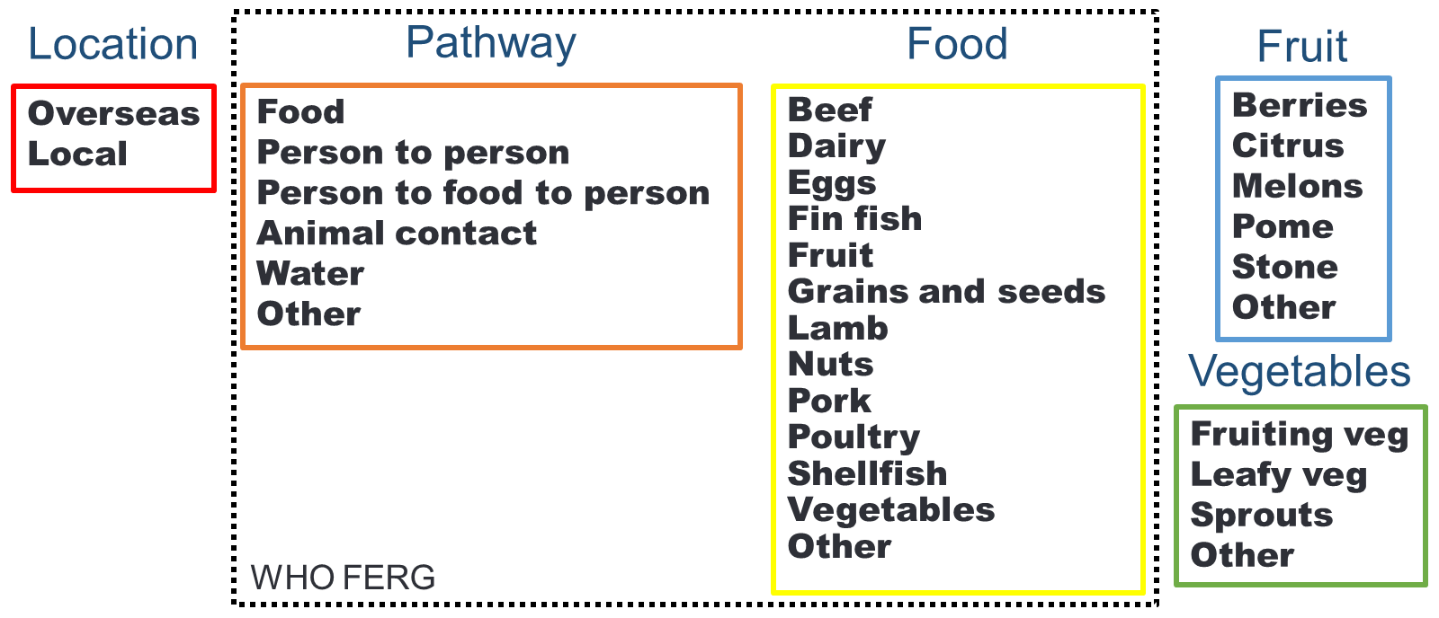

The FERG model was applied to 14 regions of the world, rather than individual countries. As a result the FERG approach was modified to account for illnesses due to hazards acquired from overseas travel (Location) and extended to incorporate fruits and vegetables (Figure 1).

A total of 12 seed questions were developed covering a range of topics including food consumption, foodborne disease outbreaks and changes in the notification rates of two notifiable diseases. The questions were from the experts’ field of knowledge, but the answers were ‘unknown’ by the experts i.e. the experts did not know the true values or have the true values readily accessible. Of the 12 questions, ten had known answers at the time of the elicitation. Experts were scored based on their performance on the seed questions, and their estimates were weighted (according to their scores) and combined into a single estimate.

The individual expert weightings using the seed questions and the elicitation question responses were analysed using the expert package in R (R Core Team 2019). The attribution percentages for each commodity/hazard combination were determined using a Monte Carlo simulation model. For example, to estimate the attribution of illness due to STEC in berries, required calculation of the proportion of STEC acquired locally in Australia, the proportion of cases that have a food exposure, the proportion from consuming fruit and the proportion from consuming berries. Each of the proportions are then multiplied together to determine the final attribution percentage. The summary values are provided in the table below.

The attribution percentages are used as an input into a cost of illness model, to estimate the total attributed burden of foodborne illness cases and associated costs.

Table 2: Median attribution percentage by pathogen and commodity pair
Commodity | Pathogen | Median % attribution
Berries | Norovirus | 0.6
 | STEC | 1.0
Leafy vegetables | Listeria monocytogenes | 7.5
 | Salmonella | 1.7
 | STEC | 5.0
Melons | Listeria monocytogenes | 8.7
 | Salmonella | 0.9
HAV = Hepatitis A virus, STEC = Shiga toxin-producing Escherichia coli

References

Glass K, Fearnley E, Hocking H, Raupach J, Veitch M, Ford L, Kirk MD (2016) Bayesian Source Attribution of Salmonellosis in South Australia. Risk Analysis 36:561-70

Hoffmann S, Devleesschauwer B, Aspinall W, Cooke R, Corrigan T, Havelaar A, et al. (2017) Attribution of global foodborne disease to specific foods: Findings from a World Health Organization structured expert elicitation. PLoS ONE 12(9): e0183641. https://doi.org/10.1371/journal. pone.0183641

R Core Team (2019). R: A language and environment for statistical computing. R Foundation for Statistical Computing, Vienna, Austria. URL https://www.R-project.org/

Varrone L, Stafford RJ, Lilly K, Selvey L, Glass K, Ford L, Bulach D, Kirk MD; CampySource Project Team (2018) Investigating locally relevant risk factors for Campylobacter infection in Australia: protocol for a case-control study and genomic analysis. BMJ Open. 2018 8:e026630. doi:10.1136/bmjopen-2018-026630

Appendix 3 – Government costs of regulatory options
This appendix presents an assessment of the cost to governments to implement and enforce the regulatory options 2 and 3. We provide a methodological discussion on how government costs can be calculated and some simplified costings for these options.

The state and territory governments are likely to incur costs associated with implementing and enforcing P1052’s proposed changes to the Code. These can be broadly grouped into three groups of activities:
- development of the implementation strategy
- physical implementation of the new regulation into the food regulatory system
- ongoing administration of the regulation.

FSANZ undertook an explorative research project in 2015 to better understand the state and territory governments’ costs associated with implementing changes to the Code. Data collected through this process suggests that implementation costs may be in the vicinity of $450,000 (2021 prices).

There will also be ongoing costs associated with maintaining business registers, audits and inspections. The approximate costs per year may be as follows:

Government costs per year | Berries (registration and one-off) | Leafy vegetables (licensing) | Melons  (licensing)
Business numbers | 750 | 640 | 225
Cost of one hour of state and territory government time | $70 | $70 | $70
Total cost of maintaining records of assumed registrations, audits and inspections  (deflated by 10 for berries*) | $5,250 | $44,800 | $15,750
*Notification for berries is one-off when a berry business starts-up, so the annual calculation of business numbers x cost of 1 hour of state and territory government time has been deflated by a factor of 10 for berries.

While the above figures have not been included in the overall costs to benefits ratios, generally government costs per year are less than 3% of total industry sector costs and make negligible difference to overall costs to benefits ratios.

These cost estimations assume that most implementation activities will only be undertaken by businesses that do not already have voluntary food safety schemes in place.

From survey and other evidence it is assumed that:
- 75% of berry producers have voluntary food safety schemes in place.
- 95% of melon producers are already on voluntary food safety schemes. The attention to health and safety has significantly increased in the melons sector in recent years.
- Only around 50% of leafy vegetables producers and processors are on a voluntary FSS.

The below framework should be used by the state and territory governments to provide workings of their cost estimates.

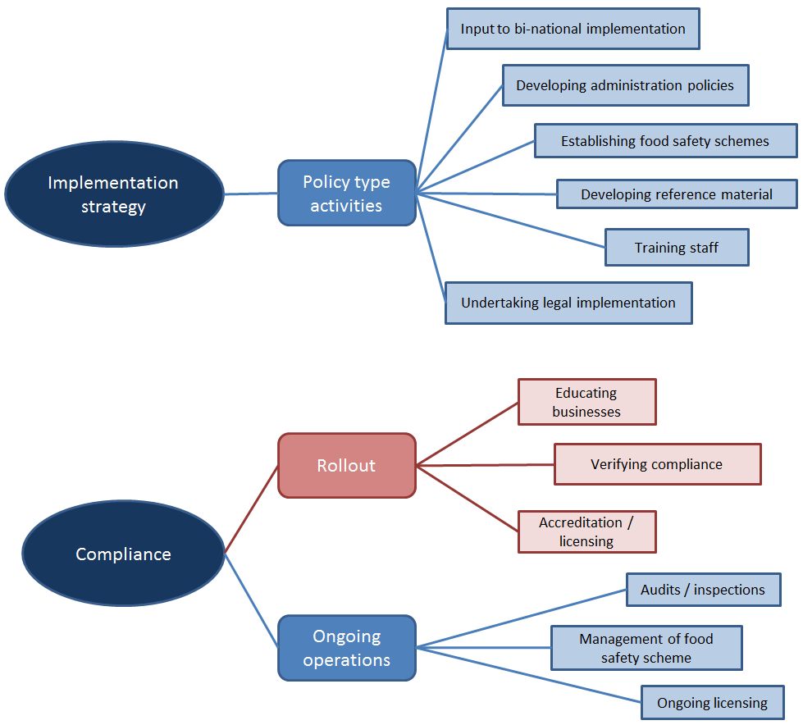

Group 1 – development of the implementation strategy

Activities in this group that are relevant to the FSANZ RIS are those that would be undertaken if a decision were made to proceed with a specific risk management option. All the previous policy work at the point of decision between maintaining the status quo or a specific intervention (regulatory or not) are sunk costs. This means that the costs and benefits included in the RIS are those that are incurred as a result of adopting the risk management option i.e. additional or incremental costs and benefits that would arise from the risk management option being incorporated into the existing food regulatory system.

Activities in this group that state and territory governments may incur costs for include:
- input to the national implementation strategy
- developing administration policies
- establishing food safety schemes
- developing reference material
- training staff
- undertaking legal implementation.

Group 2 – implementation rollout

Generally, all government actors will play a role in the implementation of a new standard. This stage often includes business licensing, any relevant audit template creation; education of councils; guidance material development; and workshops. Activities in this group that are relevant to the RIS are those that will be undertaken to rollout or physically implement a Code change into the state and territory governments’ food regulatory system, and include the following:
- Educating businesses about their new food safety obligations and verifying their compliance with the new regulation. Education may occur through newsletters, dissemination of reference material and discussions during audits, inspections or visits.
- Verification occurs during audits and inspections or via recognised third-party schemes. This activity will be measured in terms of the average increase in audit, inspection and visit times (i.e. average increase of staff time).
- Accrediting, registering, certifying and licensing businesses. If the businesses are newly captured in the food regulatory system, or the businesses are required to be re-accredited or re-licensed as part of the process for ensuring compliance with new regulation, then this activity would be captured.

Group 3 – ongoing administration of the regulation

If the businesses were not specifically captured in the state and territory governments’ food regulatory system, other than the general food safety obligations, then the ongoing associated operations or administration of the regulation would be captured in the RIS. The most significant components of assumed ongoing compliance that are incremental to current activities include:
- Any additional audits and/or inspections. These would be measured in average time for audit or inspections.
- Ongoing licensing or accreditation. The average annual management of the licensing and accreditation of businesses would be included.

Appendix 4 – Costs of the non-regulatory option
This appendix presents an assessment of the cost to jurisdictions to implement the non-regulatory option 4, which is assumed to be the same as the non-regulatory component of option 3. There are also further details about costs to industry of peak-body collaboration in the design of the non-regulatory option.

Non-regulatory measures
The additional non-regulatory measures included in options 3 and 4 are described and costed for jurisdictional regulators and for industry in Table A4(1).

The cost to individual businesses for reading the material provided, participating in webinars etc. to inform themselves of good practice (for no regulation), or of new rules (for regulation), has already been included as a cost item in Appendix 1 – Business Costs as the ‘initial costs of familiarising with new rules’.

The cost to industry, in the fourth column of Table A4(1), shows the costs of industry peak body representatives of collaborating in the design of fact sheets, animations and webinars and attending face-to-face meetings. Those costs that total $9,240 have already been counted as part of total industry costs of implementing option 3 in table 5, but assumptions behind those costs are shown in more detail in Table App 4(3) below.

Note that non-regulatory activities are not legislated and there is no mandated requirement for industry to participate in these activities under options 3 or 4.

The costs to jurisdictions, in the 3rd column of Table A4(1), of implementing non-regulatory measures are additional to the costs to jurisdictions of implementing regulations in Appendix 3 – Government costs of implementing regulatory options.

Table App 4(1) Proposed non-regulatory measures and costs
Activity | Who | Cost to jurisdictions | Cost to industry – Peak bodies component
Fact sheets | Created by FSANZ in consultation with jurisdictions and peak industry bodies.  Printed and displayed by industry. | Subtotal = $9,631 | Subtotal = $9,240  The costs of industry peak body representatives collaborating in the design of fact sheets, animations and webinars and attending face-to-face meetings.
Animations | Created by FSANZ in consultation with jurisdiction and peak industry bodies.  Used as training material by industry. | Subtotal = $5,586
Links to useful resources | Provided by FSANZ  Links to information used by industry. | Subtotal = $353
Webinars | Prepared by FSANZ and jurisdictions and peak industry bodies.  Delivered by FSANZ and jurisdictions and peak industry bodies.  Used as training material by industry. | Subtotal = $9,703
Face to face meetings with industry.  [Covid permitting.] | Prepared by FSANZ and jurisdictions and peak industry bodies.  Delivered by FSANZ and jurisdictions and peak industry bodies.  Used as training material by industry. | Subtotal = $16,735
 |  | Total = $42,007 – more details provided in Table App 4(2) | Total = $9,240 – more details provided in Table App 4(3)

Table App 4(2) details the assumptions made to calculate the costs to jurisdictions. Note that hourly rates of staff are not just the wage rate. They also include superannuation costs, office overhead costs and costs due to sick leave absences.

Table App 4(2) – Detailed calculations and assumptions for costs to jurisdictions
Activity / Materials | Description | Time | Time broken-down by EL1 and EL2 / SES hours | Hourly rate | Hours times hourly rate
Fact sheets | 6 in total (2 per commodity):  - Overview  attributed illnesses, known hazards, address food safety (the why)  - What  businesses need to now do (requirements) | 96 hours for 6 sheets at:  16 hours per sheet: 4 hours to draft; 4hr to consult for an EL1 (Executive Level 1) staff; 4hr for clearance by EL2/SES1 (Senior Executive); 2hr to design; 2hr to publish and distribute) x 6 | 72 EL1 hours = Executive Level 1  24 EL2/SES hours = Executive Level 1 or Senior Executive | $88.28  $136.44 | $6,356  $3,275
Subtotal: |  |  |  |  | $9,631
Animation | One per commodity | 60 hours for 3 animations at 20 hours per animation | 54 EL1 hours  6 EL2/SES hours | $88.28  $136.44 | $4,767  $819
Subtotal: |  |  |  |  | $5,586
Updates to website to link to useful resources | Promoting food safety culture through links to relevant industry materials | 4 hours of EL1 time | 4 EL1 hours | $88.28 | $353
Subtotal: |  |  |  |  | $353
Webinars to be done jointly with jurisdictions and/or peak industry groups | 2 to 4 lots of 1.5 hour webinars per sector over the 2.5 year implementation period | 105 hours based on 12 webinars, adding up time spent on the activities below:  45 hours preparation for 3 sectors at 15 hours preparation per sector (4 hr to draft, 8hr to consult and 3hr for clearance by EL2/SES1)  36 hours to organise webinars: 3 hours admin per webinar (agenda, speakers, invitations etc) x 3 sectors x 4 events  18 hours hosting/presenting (12 x 1.5hr)  2 hours publish presentations on website  4 hours develop follow-up materials (eg FAQ) | 96 EL1 hours  9 EL2/SES hours | $88.28  $136.44 | $8,475  $1,228
Subtotal: |  |  |  |  | $9,703
Face to Face meetings with industry  To be done jointly with jurisdictions and/or peak industry groups | 1-2 per sector over the 2.5 year implementation period | 108 hours based on 6 meetings, adding up time spent on the activities below:  90 hours travel + presenting (each meeting allowing one full day for 2 people including travel time = 15 hours x 6)  18 hours preparation/sector (3 hours each) | 108 EL1 hours | $88.28 | $9,534
Subtotal: |  |  |  |  | $9,534
Travel and Flight costs | 6 flights for 2 people: 12 flights in total at $600 per flight |  |  |  | $7,200
Subtotal: |  |  |  |  | $7,200
TOTAL COSTS: |  |  |  |  | $42,007

Table App 4(3) details the assumptions made to calculate the costs of the non-regulatory option to industry through involvement of their peak body representatives.

Table App 4(3) – detailed calculations and assumptions for industry peak body costs
Activities | Hours spent on each activity per industry representative | Number of people (peak body representatives): 2 for each of the three commodities | Number of person hours | Sub-total of costs at $70 per hour per peak body representative
Collaborating on content of fact sheets | 12 hours total, i.e.:  4 hours for webinars; 4 hours for face-to-face meetings; 4 hours for other fact sheet design activities | 6 | 12*6 = 72 | $5,040
Attending face to face meetings after fact sheet design | 6 hours total, i.e.:  2 meetings at 3 hours per meeting including short travel times. | 6 | 6*6 = 36 | $2,520
Watching/participating in webinars with Q&A after fact sheet design | 4 hours total, i.e.:  2 webinars at 2 hours per webinar | 6 | 4*6 = 24 | $1,680
Total industry cost of peak body representative involvement: |  |  |  | $9,240

Appendix 5 – Business costs of a food safety incident: a case study
Introduction

The purpose of this appendix is to describe the potential consequences of horticulture incidents using a recent incident (the 2018 multi-state outbreak of Listeria monocytogenes associated with rockmelons) as a case study. A caveat to this case study is that during the 2nd Call for Submission, Melons Australia stated that this out-break cost industry substantially more than the costs outlined here, at around $100m.

The case study will illustrate:
- the types of organisations and individuals that can be affected by an incident
- the types of costs organisations and individuals may incur
- the factors that affect the size and cost of an incident.

The incident

In 2018 an outbreak of L. monocytogenes was linked to rockmelons. Investigators eventually identified 22 confirmed cases in Australia. This included seven deaths and one miscarriage.

The rockmelons incident occurred in February 2018. Retailers started voluntarily withdrawing (and ceasing the sale of) rockmelons on 23 February and a trade level recall was initiated on 27 February. The onset of the last case was on 10 April 2018.

In addition to cases of illness, death and miscarriage, the outbreak resulted in:
- major costs for rockmelon producers who were not associated with the outbreak
- some export markets (Indonesia, Kuwait, Bahrain) temporarily banning all Australian rockmelons
- some export markets (Malaysia, United Arab Emirates) temporarily introducing additional testing requirements.

A simplified rockmelon supply chain associated with the outbreak is illustrated in Figure 1 below.

Figure 1. Simplified supply chain for rockmelons associated with outbreak

Table 2. Affected parties and types of costs incurred Individuals and organisations affected | Types of costs
Individuals who fell ill, died, experienced a miscarriage (and their families) | Pain and suffering  Productivity losses
Australian health care system | Health care costs
Federal, state and territory agencies responsible for investigating outbreaks | Staff time investigating outbreak, communicating findings  Staff time developing and implementing plan for producer of contaminated rockmelons to be cleared to start supply again  Travel costs for staff investigating outbreak  Laboratory costs
Food Standards Australia New Zealand | Coordinating recall, communicating with federal, state and territory agencies
Department of Agriculture and Water Resources | Staff time investigating where affected rockmelons were exported to, communicating with governments of export countries  Funding for a representative of the Australian melon industry to visit buyers in export markets after the outbreak to reassure them of the safety of Australian rockmelons
Austrade | Facilitating meetings with buyers in exports markets after the outbreak
Retailers | Staff time liaising with government officials, suppliers
Distributors and wholesale markets | Staff time liaising with government officials, retailers, suppliers
Producer of contaminated rockmelons | Lost sales revenue  Disposal of product  Retailer fees charged to remove products from shelves  Staff time liaising with government officials, distributors and retailers  Staff time solving problem (e.g. developing new cleaning procedures and documentation)  Changes to equipment, packing line  Additional testing requirements
Other rockmelon producers | Lost sales revenue  Disposal of product  Staff time liaising with government officials  Staff time implementing new standards  Additional testing requirements
Table continued:
Individuals and organisations affected | Types of costs
Australian Melon Association | Staff time liaising with government officials, rockmelon producers, and importers, retailers and government officials in export markets
Exporters | Staff time liaising with Australian and foreign government officials, suppliers
Rockmelons from the producer of contaminated melons were exported to: Bahrain, Hong Kong, Japan, Kuwait, Malaysia, Oman, Qatar, Singapore, UAE (WHO, 2018). They may also have been exported to Seychelles.

Table 2 lists the parties affected by the outbreak and the types of costs incurred.

Some foodborne illness outbreaks also lead to substantial legal costs for the food producer from civil lawsuits and/or criminal cases. FSANZ is not aware of any legal action being taken against the producer of contaminated rockmelons as a result of the L. monocytogenes outbreak.

Estimated economic impact

The incident year of 2018 compared to 2017:
- the price declined from $1.23 per kg to $1.11 per kg or -9.8%
- the volume declined from 26,720t to 8,312t in 2018 or -68.9%
- the market value declined from $33.0m to $9.3m or -71.9%.

The recovery year of 2019 compared to 2018:
- there was a recovery in 2019 with price increasing 26.7%, volume increasing 69.3% and the two combining to create an increase in market value of 114.6%.

Apparent residual impact:
- the change between 2017 and the recovered performance in 2019 is reflected in a 14.2% higher price, a -47.3% reduction in volume and -39.8% reduction in market value of $13.1m.

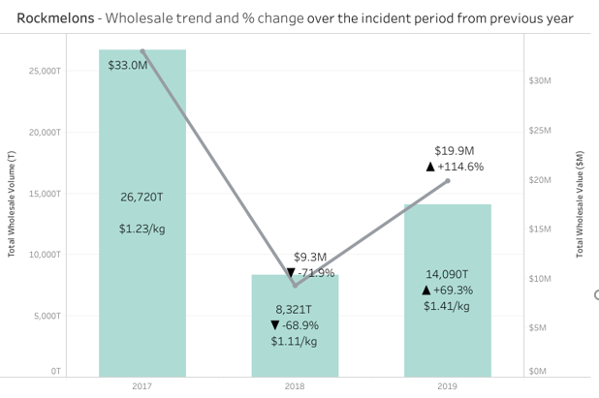
Figure 2. Rockmelon wholesale market impact

What factors affected the size and the cost of the incident?

The number of cases (and the health care and productivity losses from them) is a major contributor to the overall cost of the incident. This was affected by the time taken to identify the source of the outbreak.

The following factors contributed to identifying an outbreak:
- The incubation period for L. monocytogenes can range from 24 hours up to 67 days (Goulet, King, Vaillant, & Valk, 2013). A long incubation makes it very difficult for an ill person to recall what they ate around the time they were exposed.
- Rockmelons have a short shelf life. This, combined with the long incubation period, meant few cases would have still had the affected rockmelon in their refrigerator when they were contacted by investigators.
- Cases were spread throughout four states. Initially the investigation only examined cases in NSW. It was not until 19 February that another state (Victoria) realised they had cases linked to the outbreak.
- When the number of cases was small (i.e. at the start of the investigation and when the focus was on NSW) there was insufficient data from food recall questionnaires to narrow the source of the outbreak enough to develop a sampling plan. NSW started taking samples from suspect foods at retailers and wholesalers on 13 February.
- It takes time to obtain results on more definitive laboratory tests that can link the L. monocytogenes from cases to the L. monocytogenes on rockmelons. For example, swabs were taken from the producer of the contaminated melons on 21 February. The results demonstrating the serotypes were the same as in the cases were not confirmed until 27 February.

The size and cost of the incident was also influenced by the decisions made by some retailers. These decisions increased the cost experienced by other rockmelon producers who were not associated with the outbreak. These included:
- The decision to cease the sale of all rockmelons (not just those from the contaminated farm) on 23 February (before the outbreak was officially linked to one producer). This meant many rockmelons were not sold and had to be disposed of.
- This decision continued even once the outbreak was linked to a particular producer and a trade level recall (specific to the contaminated producer) was initiated.
- Some retailers required suppliers to meet new standards before they would agree to start buying from them again. This contributed to further lost revenue and disposal costs.

We have not asked retailers why they did not start buying rockmelons again from producers not associated with the outbreak. Evidence from overseas horticulture outbreaks suggests it is common that producers not linked to an outbreak still experience losses from lower sales and/or a fall in prices (Calvin, Avendaño & Schwentesius, 2004).

Retailers’ behaviour may have reflected a fall in consumer demand for rockmelons. By early March news stories were published attributing the L. monocytogenes outbreak to rockmelons. By this stage, any rockmelons available for sale would have been from suppliers not linked to the outbreak. However, due to the long incubation period, news outlets reported on additional cases (including deaths) that had been confirmed. Consequently, it may have seemed to consumers the issue had not been fixed and rockmelons were still risky.

Conclusion

Australia has robust food recall and incident procedures. These are supported by skilled epidemiologists and sophisticated laboratory testing capability. In this case, these systems worked well. However, the on-farm contamination of the rockmelons still resulted in a high number of cases (22) over a long time period (three months).

It appears the main strategies to reduce recall and incident costs will be to prevent the contamination that leads to the need for recalls and incidents in the first place. This would reduce the main types of costs from recalls and incidents (from individuals who become ill or die) as well as costs to government and industry.

However, this case also highlights the significant costs likely experienced by producers who were not associated with the outbreak. Melons Australia in February 2022 estimated such costs at much higher for the melons industry at $100m across the whole industry including lost sales values. Interventions that can reduce these negative effects could significantly reduce the cost of recalls and incidents.

In addition, strategies that reduce the time taken to 1) identify an outbreak is occurring, 2) link the outbreak to a particular product, and 3) link the outbreak to a particular producer would reduce both the number of cases and the costs to government and industry.

Appendix 6 – International trade
Introduction

Potential trade impacts have been raised as an issue that needs to be examined as part of the analysis of costs and benefits. Expanding exports is a key government strategy to grow the wealth of Australia and New Zealand.

Whether this proposal is likely to increase or decrease exports is unclear as the causal links are not straight forward. For example, to achieve market access for many markets it is compliance with the importing market’s standards that is of primary importance not compliance with the Australian domestic standard. This is typically achieved by exporting businesses complying with an appropriate industry food safety scheme. Industry also need to establish knowledge of and relationships within markets, develop supply chains and market their products to achieve premiums. Whether those premiums are likely to exceed the additional costs will determine what commercial decisions are made.

Domestic food safety standards could potentially impact on exports in one of four ways:

- It could impact on the cost competiveness of the industry. This could be negatively through the introduction of additional regulation or positively by deregulation.
- It could reduce trade friction (costs) by aligning domestic and destination market requirements.
- It could protect and enhance the reputation of Australia as a producer of safe food. This could allow a price premium to be achieved and/or provide clear evidence to defend against potentially spurious claims around food safety for protectionist reasons.
- High food standards provide Australia with a high level of agility in that it can easily meet the standards of multiple markets with little adjustment.

A more granular approach is needed to get a real sense of what is going on for specific horticultural products. It may be that the cost competitiveness of our production systems may be equally or even more important to our export success. This is potentially the case for the commodities being considered.

This appendix will look at the general trends associated with our exports and also look at what is specifically happening for berries, leafy vegetables and melons. It is beyond the scope of this paper to quantify the likely impact of potential changes to food safety regulation or even the net effect. However, conclusions about the potential size of any impacts and their relative importance to the overarching analysis can be made. It is unlikely that there will be significant positive impacts to exports from additional regulation for berries and leafy vegetables, although there may be greater positive impacts for melons. Only around 2% to 3% of total domestic production revenues for berries and leafy vegetable are from exports, but that is higher for melons at around 20%.

General export performance overview

The export destination of Australian produce in 2019-20 is shown in Figure 1 (Rural Bank 2020). Horticultural produce makes a significant contribution to Australian export revenue. China, the USA, Japan, South Korea and Indonesia account for 61% of Australia’s total agricultural export revenue.

Figure 1: Australian agricultural export 2019/20
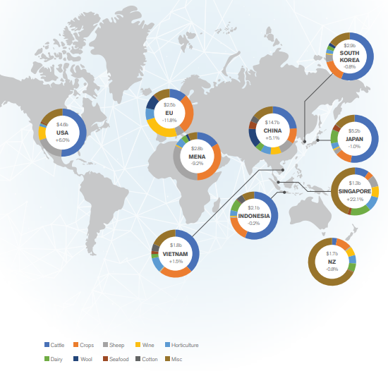

The total value of agricultural exports was AU$50.1b in 2019-20 with a compound annual growth rate (CAGR) of 5.7% over the past ten years (Rural Bank 2020). Berries, leafy vegetables and melons exports make up a very low proportion of this total value, at less than 1/600th or around 0.16% of all Australian agricultural exports.

Fruit exports include berries and melons, but also many other fruits. Fruit exports were worth $1,475m in 2019-20, a 10% increase compared to the previous year (Horticulture Innovation Australia Limited 2020b). The largest export growth rates in fruits were achieved by table grapes, citrus and stone fruits.

China remains the primary destination for Australian exports accounting for 30.3% in 2019-20, up from 28.4% in 2018-19 (Rural Bank 2020) as shown in Figure 2. The strongest export growth rate to China was recorded for beef followed by sheep meat, wheat, canola and nuts. While exports to Japan, South Korea and Indonesia declined, exports to Vietnam has recovered in year 2019-20, after two consecutive years of decline. Vietnam is reported to be a promising destination for Australian agricultural exports recording a 10-year CAGR of 13.3%. Exports to the US has shown an increase with an value of $264.2m, up from 2018-19 by 5.1%, driven by the increased beef exports.

Figure 2: Value of top 10 Australian export markets in 2018-2020
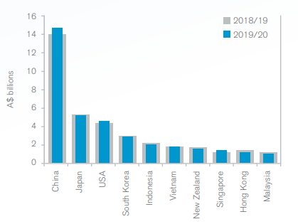

A snapshot of agricultural commodity statistics shows that the horticulture sector representing fruit and vegetables (Department of Agriculture, Water and the Environment 2021) has increased in production by 24% and exports by 64%, between 2001-02 and 2019-20 (Figure 3).

Figure 3: Production value of Australian agriculture commodities. Percentage changes compare levels between 2001-02 and 2019-20.

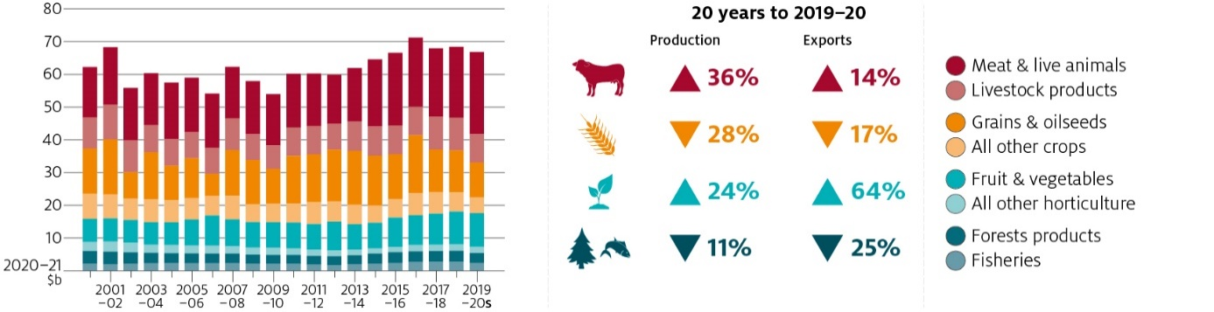

The export value of horticultural produce under the category ‘Edible fruit and nuts; peel of citrus fruit or melons’ for the five years to 2020 is listed in Table 1 (International Trade Centre). The export value of most horticultural commodities, particularly berries, melons and fruits have shown an increase in 2019 compared to the previous years, however the export values generally dropped in 2020.

Table 1: Australian exports for the category ‘Edible fruit and nuts; peel of citrus fruit or melons’
Code | Product label | Exported value (in $thousands)
 |  | 2016 | 2017 | 2018 | 2019 | 2020
0802 | Other nuts, fresh or dried, whether or not shelled or peeled (excluding coconuts, Brazil nuts . . . | 783,919 | 761,465 | 900,458 | 1,158,073 | 964,146
0806 | Grapes, fresh or dried | 461,530 | 407,258 | 421,842 | 617,787 | 637,864
0805 | Citrus fruit, fresh or dried | 337,623 | 453,150 | 462,314 | 548,472 | 493,635
0809 | Apricots, cherries, peaches incl. nectarines, plums and sloes, fresh | 110,105 | 108,407 | 156,038 | 188,465 | 178,238
0804 | Dates, figs, pineapples, avocados, guavas, mangoes and mangosteens, fresh or dried | 44,271 | 44,867 | 48,966 | 55,433 | 53,972
0810 | Fresh strawberries, raspberries, blackberries, back, white or red currants, gooseberries and . . . | 49,968 | 47,240 | 42,436 | 52,198 | 49,809
0807 | Melons, incl. watermelons, and papaws (papayas), fresh | 33,639 | 36,757 | 32,582 | 43,720 | 29,473
0808 | Apples, pears and quinces, fresh | 32,267 | 27,849 | 29,731 | 28,123 | 20,950
0813 | Dried apricots, prunes, apples, peaches, pears, papaws "papayas", tamarinds and other edible . . . | 7,961 | 8,795 | 15,140 | 15,746 | 14,564
0811 | Fruit and nuts, uncooked or cooked by steaming or boiling in water, frozen, whether or not . . . | 3,171 | 3,945 | 3,414 | 4,004 | 3,372
0801 | Coconuts, Brazil nuts and cashew nuts, fresh or dried, whether or not shelled or peeled | 2,698 | 3,546 | 1,439 | 1,812 | 1,706
0814 | Peel of citrus fruit or melons, incl. watermelons, fresh, frozen, dried or provisionally preserved . . . | 551 | 1,194 | 2,211 | 36 | 599
0812 | Fruit and nuts, provisionally preserved, e.g. by sulphur dioxide gas, in brine, in sulphur . . . | 343 | 2,733 | 4,195 | 854 | 291
0803 | Bananas, incl. plantains, fresh or dried | 288 | 333 | 210 | 411 | 169

The vegetable export value was projected (Department of Agriculture, Water and Environment, ABARES 2021) to increase from $457m to $565m between 2018-19 and 2025-26. Similarly, exports of fruits were projected to increase from $1,493m to $1,783m for the same period.

Specific commodity assessment

In this section melons, berries and leafy vegetables are individually assessed looking at total production volume, value, exports and export competition. Most of the statistics presented below for melons, berries and leafy vegetables, were extracted from the Australian Horticulture Statistics Handbook ((Horticulture Innovation Australia Limited 2020b).

Melons

The main species of melons produced in Australia are watermelon, rockmelon and honeydew melon, with some production of piel de sapo. Varieties grown vary depending on market conditions and consumer preference. The term ‘muskmelons’ is used to describe rockmelon, honeydew melon and piel de sapo. For this document, the term ‘melon’ will be used to collectively discuss watermelon, rockmelon, honeydew and piel de sapo melons.

Watermelon is the most common melon grown, accounting for nearly 70% of production. Most melons produced in Australia are sold on the domestic market as either fresh whole or fresh cut fruit.

In the financial year ending 2020, Australia produced 190,024t of melons with a production value of $152m. The total 2019-20 fresh melon export volume (21,772t), and value ($39m) increased by 1.5% and 5.1% respectively, compared to the previous financial year. Melon imports are minimal (155t) leading to a positive net melon international trade. The proportion of melons exported from the total production in Australia is 11.5% in volume and 25.7% in value. That proportion is notably higher than for berries and leafy vegetables.

Muskmelon

Muskmelon includes rockmelons and honey dew melons, which contribute to 85% and 14% of the total muskmelon production respectively. For the financial year ending June 2020, the total production was 58,136t for a value of $68m. The total 2019-20 fresh muskmelon export volume (14,887t), and value ($26m) increased by 5% and 8% respectively, compared to the previous financial year. There has been no imports of muskmelon reported for year 2019-20 leading to a positive net muskmelon international trade.
The proportion of muskmelons exported from the total production in Australia is 25.6% in volume and 38.3% in value.

The muskmelon export trend shows an increase (Horticulture Innovation Australia Limited 2020b) in the total export value by 52% since 2013 (Figure 4). The graph shows export values for the period between 2013 and 2019. The destination export countries are primarily Singapore, Japan and New Zealand.

Watermelon

The total watermelon production for the financial year ending June 2020 was 131,889t for a value of $84m.

The watermelon export trend shows a steady increase since 2013 with a steep rise in 2019 (Horticulture Innovation Australia Limited 2020b). The total export value has increased by 77% during this period (Figure 5). The destination export countries are primarily United Arab Emirates (UAE) and New Zealand.

Figure 4: Muskmelon export trend and destinations
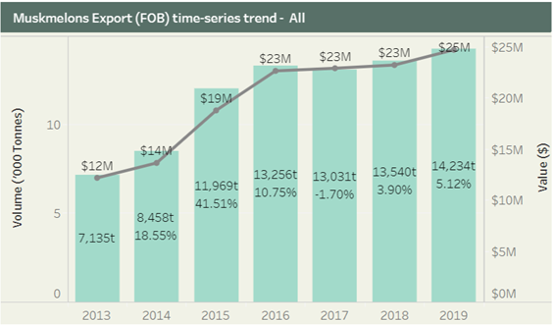
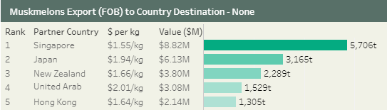

Figure 5: Watermelon export trend and destinations
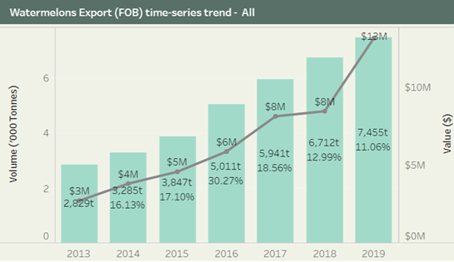
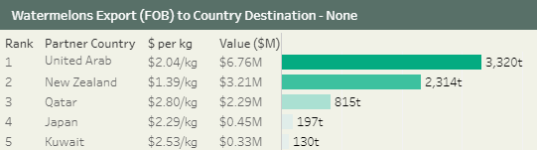

Berries

Blueberries, blackberries, raspberries and strawberries are the four major berries grown in Australia including multiple varieties of each berry type. The other berries grown in minimal quantities in Australia are boysenberry, loganberry, silvanberry and youngberry, the rubus hybrid cultivars.

Australian berry export volume in 2019-20, 5,084t ($42m) is small compared to the production volume, 113,025t ($1,041m). Strawberry is the major berry exported followed by a small volume of blueberry and rubus berry. Strawberry has had a significant 81% increase in export value since 2013 (Figure 6). Strawberry is primarily exported to Thailand, Singapore, New Zealand and UAE. Strawberry exports ($33m) only account for around 7.7% of production sales values ($435m) for berries.

Figure 6: Strawberry export trend and destinations
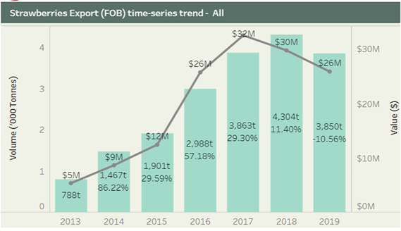
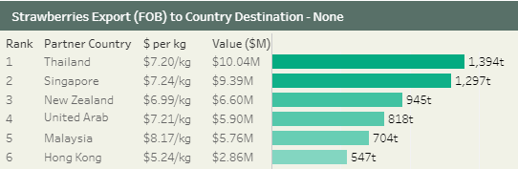
Vegetables

It has not been possible to find completely disaggregated statistics for leafy vegetables. However, it has been possible to find statistics for vegetables. Australian vegetable production accounts for about 7% of the gross value of agricultural production in 2017–18 (ABARES, 2019). Due to the increased domestic demand for fresh and local produce and the continued demand from the export market, vegetable growers continue to invest in capital additions to the farm. In 2016-17, a total of $319m of new investment was seen within the sector. The gross value of vegetable production increased by 24% since 2013 with a value of $4.851 billion in 2019–20, where head lettuce ($206m) rank in the top leafy vegetables produced in Australia (Horticulture Innovation Australia Limited 2020b).

Over the medium term, vegetable production is expected to increase from the expansion of new varieties of leafy and easy-to-process vegetables such as leafy vegetables and snacking varieties and protected environment farming practices. The productivity gains driven by the shift to greenhouse production has extended tomato production and is projected to increase from 405,000t in 2017–18 to 425,000t in 2022–23 (Department of Agriculture, Water and Environment, ABARES 2018). The upward export trend in vegetables such as broccoli, brussel sprouts, cauliflower, celery, lettuce, mushrooms, pumpkins and spinach in the target markets (Figure 7) is further enhanced due to the value-adding opportunities for fresh and easy-to-process vegetables in Australia (minimally transformed vegetables including cut, washed, mixed, packed and frozen vegetables).

Figure 7: Value of Australian vegetable exports to selected markets, 2012-2017.
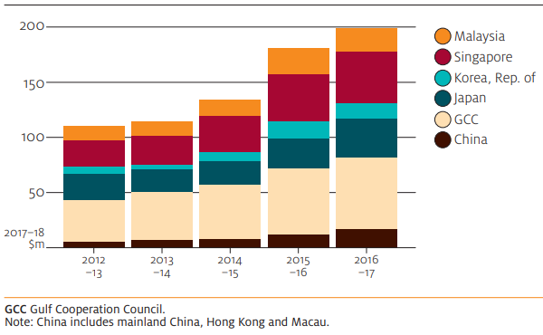

The long-term data (Rural Bank 2020) for vegetable shows that the export value (Figure 8) took a dip after the start of the century, but picked up exports in the last five years.

In the year 2019-20, Australian vegetable exports dropped, due to the impacts of drought and the consequent high water prices. The export value of the vegetable market declined for the first time in eight years in 2019-20 by $15.8m (5%) to $296.3m for a total tonnage of 216,960t of vegetables, a 10% decrease from the previous year. These decreases were attributed by the low production of carrot, onion and asparagus (Figure 8), while potato export volume and value increased due to the supply gap from Europe in 2018-19 (Rural Bank 2020).
Figure 8: Australian vegetable export value

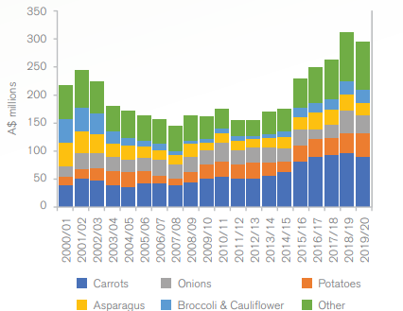

The long-term statistics data for the Australian economic value of vegetable production and export comparison extracted from Agricultural commodity statistics (Australian Bureau of Agricultural and Resource Economics and Sciences 2019), reflects an average export value of 10% of the production value (Figure 9).
Figure 9: Australian vegetables production and export statistics for 30 years

The vegetable export value is dominated by the Middle East and North Africa (MENA) region and Singapore (Table 2), while exports to Japan have dropped due to the reduction in supply (Rural Bank 2020). Thailand and Malaysia are the emerging markets creating more export opportunities for vegetables. For example, in Thailand, potato imports attract zero tariff (Shaun Lindhe 2020) and this could increase export value in the future.

Table 2: Value of Australia’s top 10 vegetable export markets
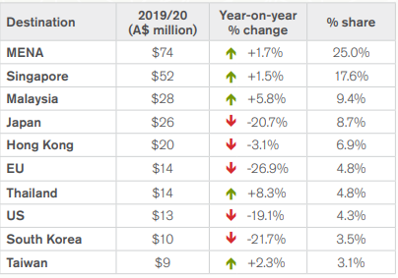

Export competition

Australian fruit export to selected Asian countries (Figure 10) has seen high competition from countries like Chile (berries, cherries and stone fruits), and Peru for table grapes (Department of Agriculture, Water and Environment, ABARES 2018). These countries have increased their production levels enabling them to move larger volumes into China competing with Australia.

Figure 10: Value of fruit exports to selected Asian countries by Australia and its major competitors, 2010 to 2015

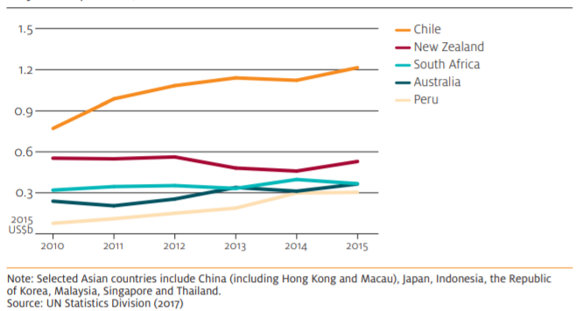

Figure 11: Comparison of fruit and nut imports in China from selected southern hemisphere countries, 2016 to 2019

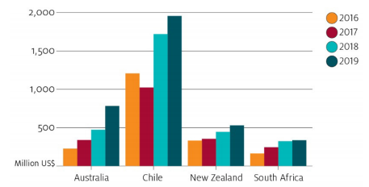

The commercial ties between China and Chile was further enhanced by the China–Chile Free Trade Agreement, upgraded in 2017 (China FTA Network 2017), to reduce investment barriers in transhipment arrangements, cold storage and expansion of distribution networks in China (Department of Agriculture, Water and Environment, ABARES March quarter 2019). This was reflected in the steep increase in 2018 of Chilean imports in China. Though Australia is performing better than New Zealand and South Africa in fruit and nut exports to China, the increased imports from Chile potentially impacts exports from Australia into China (Figure 11).

It is possible to examine the prices Australian producers of lettuce (a sub-set of leafy vegetables), melons and berries are receiving in export markets. Two sources of data were used to compare Australian export prices with exports of competitor countries, i.e. Comtrade data and Trademap. Both data sources gave the same conclusions for lettuces, berries and melons. The vast majority of these exports from Australia and our competitors are to emerging and developed Asian countries, the higher-income Middle East counties, Western Europe and North America.

As shown below, Australian export prices for lettuce are around 30% higher than those of our next highest priced competitors (Figure 12). It is difficult from that data to know whether lettuces generate more profits than our competitors, as our underlying costs of taking the lettuces to market may also be higher. Australian lettuce exports also only generate revenue of around $10m to $15m a year, with other leafy greens and fresh salads adding around $5m. Those values are very small in the overall context of the total export value of all horticulture being worth over $2,645.7m in 2019.

Australian export prices for melons and berries are markedly lower than most of our competitors, as shown in Figures 13 and 14.

Berries and melons exports are also relatively small, generating annual revenues of around $34m and $37m respectively.

Figure 12: Unit export value for lettuce (Comtrade data)

Figure 13: Unit export value for melons (Comtrade data)

Figure 14: Unit export value for berries (Comtrade data)

The statistics provided suggest that export markets are not a large focus for Australian leafy vegetable and berry producers with domestic markets providing the majority of their revenue. It also indicates that Australian producers are not receiving any sort of price premium for berries or melons relative to countries that we would traditionally characterise as having less developed domestic food safety regulation. This suggests that other factors such a taste and quality (which potentially diminishes quite rapidly for these products) may be driving sales. Industry also need to establish knowledge of and relationships within markets, develop supply chains and market their products to achieve premiums. Whether those premiums are likely to exceed the additional costs will determine what commercial decisions are made. It also suggests that the price competitiveness of production is probably quite important to maintain a position in these markets.

Summary

Australian food is well-recognised internationally for its quality and safety creating market access in several export countries at premium pricing. A long-term view of horticultural commodity statistics shows that production and exports have increased by 24% and 64%, respectively, since 2001-02. The future projections for the exports of both fruits and vegetables could also be very promising although presently uncertain given the effects of the COVID-19 pandemic.

However, when a more granular approach is taken for specific commodities it becomes clear that different markets can work quite differently. It is also not clear that a simple focus on increasing food safety standards is always appropriate and that we also need to be focussed on the relatively cost competitiveness of our producers. Exports only account for a small (but potentially growing) percentage of berries sales value (around 3%). Leafy vegetables (Australian lettuce exports) also only generate export revenue of around 2-3% of sales value at $10m to $15m a year, with other leafy greens and fresh salads adding around $5m. A more substantial proportion of melons is being exported (20.4% of sales value). Evidence of any sort of price premium only exists for lettuces, with lower prices being received for melons and berries than most like export countries.

It is unlikely that impacts on trade for these commodities will be significantly material to consideration of the costs and benefits for P1052 for leafy vegetables and berries. There is a strong domestic production focus for these industries and price premiums over competing exporters appear limited.

Note: There could be somewhat larger and possible positive (but unknown) trade impacts for melons that export over 20% of domestic production values.

References
Abelson P, Forbes MP, Hall G (2006) The annual cost of foodborne illness in Australia
Australian Bureau of Agricultural and Resource Economics and Sciences (2019) Agricultural commodities and trade data. 2019: Rural Commodities - Horticulture. https://www.agriculture.gov.au/sites/default/files/documents/ACS2019_HorticultureTables_v1.0.0.xlsx. Accessed 9 November 2020
China FTA Network (2017) China-Chile FTA Upgrading Negotiations Concluded, Agreement Signed. http://fta.mofcom.gov.cn/enarticle/enchile/enchilenews/201712/36339_1.html. Accessed 12 November 2020
Department of Agriculture, Water and Environment, ABARES (March quarter 2019) Agricultural Commodities. Commodities forecast and Outlook. 2019. https://www.agriculture.gov.au/sites/default/files/sitecollectiondocuments/abares/agriculture-commodities/AgCommodities201903_v1.0.0.pdf
Department of Agriculture, Water and Environment, ABARES (2021) Agricultural commodities data tables. https://www.agriculture.gov.au/abares/research-topics/agricultural-outlook/agriculture-overview. Accessed 22 April 2021
Department of Agriculture, Water and the Environment (2020) Australian commodities and trade data: Agricultural commodity statistics. https://www.agriculture.gov.au/abares/research-topics/agricultural-outlook/data#2020
Department of Agriculture, Water and the Environment (2021) Snapshot of Australian Agriculture 2021. ABARES insights. https://daff.ent.sirsidynix.net.au/client/en_AU/search/asset/1031521/0
Department of Health (2014) Foodborne Illness in Australia: Annual incidence circa 2010
Horticulture Innovation Australia Limited (2020a) Australian Horticulture Statistics Handbook 2018-19. Fruit. https://www.horticulture.com.au/growers/help-your-business-grow/research-reports-publications-fact-sheets-and-more/grower-resources/ha18002-assets/australian-horticulture-statistics-handbook/. Accessed 11 September 2020
Horticulture Innovation Australia Limited (2020b) Australian Horticulture Statistics Handbook 2019/20. https://www.horticulture.com.au/growers/help-your-business-grow/research-reports-publications-fact-sheets-and-more/grower-resources/ha18002-assets/australian-horticulture-statistics-handbook/. Accessed 22 April 2021
International Trade Centre Trade Map. International Trade Centre.: Trade statistics for international business development. Monthly, quarterly and yearly trade data. Import & export values, volumes, growth rates, market shares, etc. https://www.trademap.org/. Accessed 21 September 2020
Shaun Lindhe (2020) Potato News Today. AUSVEG. 2020: Potato growers to benefit as Thailand lifts tariffs on Australian potatoes. https://www.potatonewstoday.com/2020/07/27/potato-growers-to-benefit-as-thailand-lifts-tariffs-on-australian-potatoes/. Accessed 13 November 2020
Tom Jackson, Kirk Zammit and Steve Hatfield-Dodds (2020) Insights, Issue 1: Snapshot of Australian Agriculture 2020. https://daff.ent.sirsidynix.net.au/client/en_AU/search/asset/1029981/0. Accessed 16 October 2020

Appendix 7 – Consumers
This appendix discusses the possible impacts of regulatory changes to horticultural produce on consumer purchasing behaviours. It is assumed that regulatory changes may translate into an increased cost of horticultural produce for consumers. From a search of research publication databases available to FSANZ there is an apparent lack of Australian evidence concerning consumers in relation to horticultural produce. As such, available international research has been reviewed to investigate plausible consumer outcomes following potential regulatory change. Strong behavioural predictions cannot be made at this time without additional research.

Key concepts in this section are:
- consumers’ willingness to pay (WTP) for an increase in food safety, assuming costs of horticultural produce would increase as a consequence of regulatory change
- whether a change in the price of horticultural produce impacts consumer demand.

Willingness to pay in the context of horticultural food safety regulation is the maximum amount of money consumers are willing to pay for an increase in the safety of horticultural produce. From a search of literature databases available to FSANZ, two papers from the United States were identified examining consumers’ WTP for an increase in fruit and vegetable safety. Fruit and vegetables as food categories are considered reasonable proxies to the Australian category of ‘horticultural produce’. Whether the United States context of these papers readily translates to the Australian context is unknown. As such, caution should be taken when interpreting conclusions as they may not represent Australian consumer purchasing behaviours.

One study (Yu et al, 2018) examined both consumer risk perceptions toward fresh cut produce and their willingness to pay for an increase in food safety. The study was conducted across ten regions of the United States. 937 valid responses were obtained. Of the responses gathered 61.8% were female and 38.2% were male. Most participants were millennials (54.4%) with generation X accounting for 21.6% of the sample and baby boomers making up the final 23.9%. Nearly 40% of respondents had obtained a college degree or higher. Around 20% reported earning a low income of $35,000USD or less, close to 50% reported earning a middle income between $35,000USD and $80,000USD, with 30% reporting a high income above $80,000USD.

Concerning risk perceptions toward fresh cut produce, the study found respondents were significantly more concerned with pesticides than either food safety, genetic modification (GMO) or antibiotics. Food safety was identified as the second most important perceived risk concern. GMO and antibiotic concerns were found to be of equal concern below pesticide and food safety concerns. The results indicate age (by way of generation) and gender were significant factors in participant responses. Millennials had greater concerns than baby boomers regarding foodborne pathogens, and it was observed that females overall were found to be more concerned with food safety than males in this study.

Many respondents (64.2%) indicated they would be willing to pay an extra dollar for bagged salad to improve food safety by 50% (the average price for a bagged salad being $3USD). The factors influencing respondents willingness to pay were; respondent risk perceptions, income, their generation, frequency of purchasing fresh cut produce, as well as the interaction between their perception of risk with the frequency of their purchasing fresh cut produce. Those with higher risk perceptions, higher incomes, who are younger, and frequently purchase fresh cut produce are more likely to be willing to pay more.

A second study from the United States (Naanwaab et al, 2014) examined consumers’ willingness to pay for a treatment process (bacteriophage treatments) that would reduce bacteria related foodborne illness in fresh produce. In total 210 respondents from Alabama, Georgia, South Carolina and North Carolina gave valid responses. Close to 63% were female and 37% were male. Close to 35% reported having a college education and close to 45% reported completing high school. Concerning income, 36% earned between $10,000USD and $25,000USD, 31% earned between $25,001USD and $50,000USD, 24% earned between $50,001USD and $75,000USD. The remaining 9% of participants earned either less than $10,000, or over $75,000.

The findings in this second study found higher incomes (>$50,000USD) doubled the odds respondents would be willing to pay between 10 to 30 cents USD more per pound for fresh produce treated in order to reduce bacterial pathogens. The authors of the study had initially hypothesised that gender and education would be significant factors in respondent willingness to pay, but this was found not the case in this study. The authors of the study noted income and education were highly correlated. As such, it may be that education by itself is not a singular influential factor, but when education interacts with income it may be a factor. The authors of this study however did not test this possible interaction.

The studies mentioned above have limitations. The first is they are from the United States and may not translate readily to an Australian context. The second is that neither study specifically examines the types of produce this proposal seeks to address. A third limitation is WTP studies may not reflect normal situations consumers encounter when making purchase decisions.

Despite these limitations the two studies identify that when consumers are informed about a potential price increase for safer fresh produce, generally those with higher incomes are more likely to be willing to pay more. In the study conducted by Yu and colleagues (2018) it was further identified that an individual’s risk perception in relation to fresh cut produce was also a factor in their willingness to pay more for safer produce. Of interest in the study by Yu and colleagues (2018) was the finding that consumer risk perceptions moderated their willingness to pay more (i.e. higher risk perceptions lead to greater willingness) for safer fresh cut produce amongst those who frequently purchased such goods. A plausible explanation for this finding is those who frequently buy fresh cut fruits and vegetables, and who have a greater understanding of food safety risks, are willing to pay more for safety as there is no substitute for such foods.

Given a common finding of the above studies is income appears linked to a consumer’s willingness to pay more for greater food safety, it is arguably important to consider what the demand elasticity surrounding horticultural produce is as well.

A search of literature databases available to FSANZ concerning demand elasticities3 for food in Australia revealed a journal article of interest (Ulubasgolu et al, 2015). The article reports fresh fruit in Australia is estimated to have unit-elastic demand, whereas fresh vegetables were found to be inelastic. The article also reported inversely that preserved fruit was inelastic, and preserved vegetables were elastic. The results suggest that for Australian consumers fresh fruit is more effected by price changes than vegetables. As the price of fruit increases, demand decreases at the same percentage rate. Fresh vegetable demand on the other hand is not as influenced by price variability with demand reducing in percentage terms less the price.

In addition to the Australian study above, a systematic review (Andreyeva et al, 2010) of food demand elasticity research in the United States has been identified. The review examined 160 studies conducted in the United States concerning demand elasticity. Of the 160 studies identified 18 examined the demand elasticity of fruit and vegetables which are considered to be a proxy for horticultural produce in the Australian context.

The review found in averaging the findings of 20 estimates of demand elasticity in relation to vegetables it is inelastic with a 95% confidence interval surrounding that average. That is, the relationship between cost and demand does not change very much with respect to the purchasing of vegetables. From 20 estimates concerning the demand elasticity for fruit it was found to be inelastic too. Unlike the category of vegetables though, there appears to have been an upper estimate from one study indicating a degree of elasticity suggesting a 10% increase in price would lead to a 30% reduction in demand. However, the averaging of results of the 20 fruit observations with a 95% confidence interval indicates the category may be inelastic as the upper bound of the confidence interval is close but short of indicating elasticity. A limitation of this review is once again it concerns research originating from the United States.

In conclusion, a couple of US studies suggest that consumers may be willing to pay extra for produce that is safer, especially higher income consumers. As is to be expected demand is likely to decrease if regulatory changes end up pushing costs up for consumers. However, an Australian study indicates that demand for fresh vegetables is likely be inelastic (to decrease less in % terms than any % change in price) and is unit-elastic for fruit (the decrease in demand in % terms is the same any % change in price). A larger group of studies looking at this issue in the US suggests both are price inelastic in the context of the US market at least. This suggests that the net impact in terms of consumer demand should be relatively benign, but further research is needed before being able to offer a definitive view in the context of these specific commodities covered by this proposal.

Higher prices would also be expected to impact people on low incomes the most negatively compared to other population groups, whether through low income people reducing consumption or experiencing greater financial hardship.

References

Andreyeva, T., Long, M. and Brownell, K., 2010. The Impact of Food Prices on Consumption: A Systematic Review of Research on the Price Elasticity of Demand for Food. American Journal of Public Health, 100(2), pp.216-222

Naanwaab, C., Yeboah, O., Ofori Kyei, F., Sulakvelidze, A. and Goktepe, I., 2014. Evaluation of consumers’ perception and willingness to pay for bacteriophage treated fresh produce. Bacteriophage, 4(4), p.e979662.

Ulubasoglu M, Mallick D, Wadud M, Hone P, Haszler H, 2016. Food Demand Elasticities in Australia. Vol. 60, pp. 177-195, Australian journal of agricultural and resource economics, London, Eng., C1

Yu, H., Neal, J. and Sirsat, S., 2018. Consumers' food safety risk perceptions and willingness to pay for fresh-cut produce with lower risk of foodborne illness. Food Control, 86, pp.83-89.

Includes rockmelon, honeydew melon and piel de sapo melon
Previously Tasmanian Quality Assured Inc. changed its name to TQA Australia.
In addition, two cases of listeriosis in Singapore were linked to the outbreak.
Some of these bans were relatively short (e.g. Kuwait’s ban only lasted one week). However, Bahrain’s ban lasted over 12 months Fullelove (2019a).
Costs experienced by the producer are based on general food incident costs and available information specific to this incident. As a trade level recall resulted, it is assumed notification costs (e.g. press advertisements) are zero. The producer ceased production for six weeks.
To be cleared by the state regulator to supply rockmelons again, the company had to undertake regular mandatory testing. The company also did extra voluntary testing. In addition, some export markets imposed additional testing requirements (Hold, Test and Release examination) on rockmelons from the producer. Some export markets temporarily imposed such requirements for all rockmelons from Australia (Fullelove, 2019b).
All major supermarkets voluntarily withdrew rockmelons (from all suppliers) in late February 2018. Some started restocking rockmelons late March. Others did not restock until April. In addition, some export markets switched to sourcing rockmelons from other countries (Fullelove, 2019b).
Some supermarkets introduced new standards for suppliers. Suppliers needed to meet the new standard (and have an inspection demonstrating this) before the supermarkets would stock their products again.
Freshlogic report 2020 for FSANZ.
Analysis of a 2008 outbreak of L. monocytogenes from processed meat in Canada found case costs (including deaths) accounted for around 67% of total costs from the outbreak (Thomas et al. 2015).
For example: https://www.sbs.com.au/news/third-person-dies-following-listeria-outbreak
https://comtrade.un.org/
https://www.trademap.org/
1. Databases searched: FSTA – Food Science and Technology Abstracts, Food Science Source, Medline with Full Text, Science Direct, SocINDEX with Full Text. Boolean/Phrase Search Terms used in EBSCO Discovery Service: AB (Horticulture OR Fresh Produce) AND AB Consumer* AND AB Safe*. Search was limited to Articles published in English and linked to full text articles. 2. Fresh cut produce is defined as “any fresh fruit or vegetable that has been physically altered from its original state, but remains in a fresh state”.
3. Price elasticity measures how much the quantity of supply of a good, or demand for it, changes as its price changes. If the percentage change in quantity is more than the percentage change in price, the good is price elastic; if it is less, the food is price inelastic. If it is the same it is unit elastic. It is a useful measure to consider when considering what the market outcome will be from a price change. For example if a firm increases the price of a good whose demand is elastic they may actual reduce their profit.

